

School of Computing and Mathematics

PRCO303

Final Stage Computing Project

BSc (Hons) *Computer Networks*

***Gayantha Kasun Withanage***

**Plymouth ID - 10602159**

**Rescue Monitoring System**

2018/2019

**Supervisor – Dr. Prabath Weerasinghe (NSBM Green University Town)**

# Acknowledgement

First and foremost, I would like to thank the Supervisor, Dr. Prabath Weerasinghefor the constant guidance, constructive advice, enthusiasm and encouragement during this undertaking. I immensely grateful.

Secondly, I’d thank to Dr. Rasika and every one the participants who sacrificed their valuable time to helped me staggeringly, to with success complete this project.

Next, I would also like to thank my parents for their constant motivation and support throughout this Endeavour. Finally, I would also like to thank all my friends and all the people who assisted me in any way in order to make this Final project a success.

Thank you.

# Abstract

This is an Arduino and web based project which the user can remotely control in an emergency need. If there is any disaster, before the people involve, this robotic component can take the photos and video about the current situation. In current situation our country has no equipment like this. In any emergency or disaster people will involve that incident and get the necessary support. In that case they might be hurt or damage according to the condition. So that’s the main reason why I introduced this system to community. By using this system, we can reduce the damage, cost and calculate how many rescue team’s needs for that particular incident. And the system handler can estimate the necessary actions to solve that disaster or incident. We can measure the heat differences in that incidents using the Arduino equipment. Also the live stream will help us to identify all the current situation about the disaster. To store the incidents that has happened we use a web. The web site will contain all the past incidents with details. By using the web, we can send the urgent messages for the rescue teams for support. So this system will help us to save the people life and get the quick reactions in any incident.

Keywords: Arduino, Web Application, Wireless Communication, Live stream

Requirements: Database, ASP.net, Arduino IDE, Server Connection

Table of Contents

Acknowledgement 2

Abstract 3

1.0 Introduction 6

2.0 Background, Objectives & Deliverables 7

2.1 Overview of the System 7

2.1.1 AIM 7

2.2 Business Case 8

2.2.1 Business Need 8

2.2.2 Business Objectives 8

2.3 Project Objectives 9

2.4 Deliverable Parts 10

2.4.1 Arduino Robot 10

2.4.2 Temperature Displayer 10

2.4.3 Web Application 10

3.0 Method of Approach 11

3.1 Design and Development Plan 11

3.2 Product Produced and Product Quality 12

3.2.1 Process of the Arduino Equipment 17

3.2.2 Configuration of the Temperature sensor 21

4.0 Network Communication 29

4.1 Network Components 29

4.2 Network Monitoring Tools 30

5.0 Web 34

5.1 Designing the web 34

5.2 User Control 36

5.3 Database 37

5.4 Validation 38

5.5 Response 39

6.0 Project Management 40

6.1 Initial Project Plan 40

6.2 Investigation Stage 41

6.3 Design Stage 41

6.4 Communication Plan 41

6.5 Risk Management 42

6.6 Cost Estimation 42

7.0 Requirements 43

7.1 Functional Requirements 43

7.2 Non Functional Requirements 43

8.0 Testing 44

8.1 Functional Testing 44

8.2 User Testing 45

9.0 End Project Report 47

9.1 End Project Summary 47

9.2 Project Objective Review 47

10.0 Post Mortem 49

10.1 Development process and Technologies 49

10.2 Personal Performance and Lessons Learnt 49

11.0 Backup Plan 51

12.0 Conclusion 52

13.0 Bibliography 53

14.0 Appendix 54

14.1 Appendix 1 – PID 54

14.2 Appendix 2 – Interim Report 1 58

14.3 Appendix 3 – Interim Report 2 61

15.0 Supervisory meeting minutes 68

# 1.0 Introduction

This is an Arduino and web based project which the user can remotely control in an emergency need. If there is any disaster, before the people involve, this robotic component can take the photos and video about the current situation. And the system handler can estimate the necessary actions to solve that disaster or incident. To store the incidents that has happened we use a Web application.

# 2.0 Background, Objectives & Deliverables

## 2.1 Overview of the System

Disaster can happen in anywhere at any time. So I introduced this system because in our country there is no any rescue monitoring system in current. If there is any emergency people will involve for that. In many cases people face for accidents and serious damages in that situation. To avoid that I introduce this system. People can identify the heat measurement by using this system.

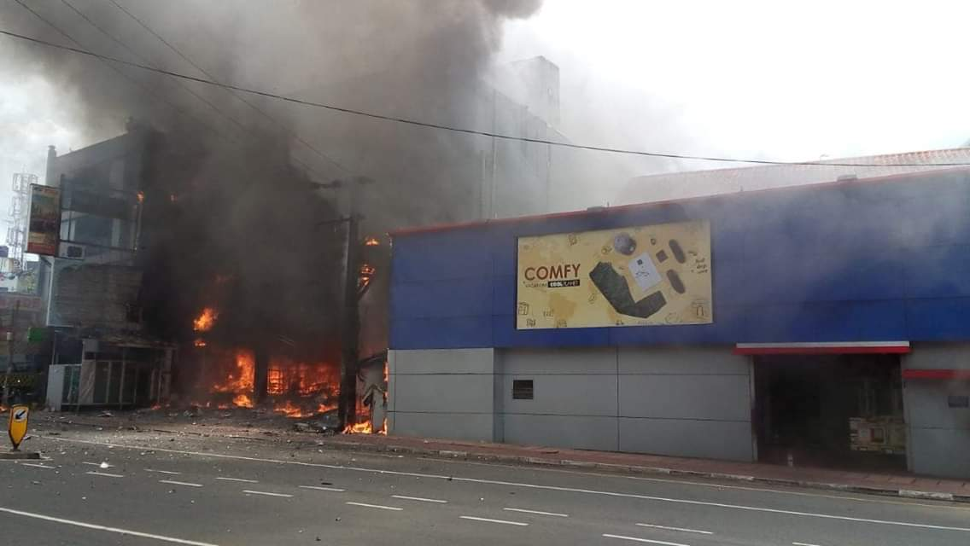 (D Ruwandi, 2018) – Fire at Cool Planet

### 2.1.1 AIM

The aim of this project is to prevent a good solution for any emergency need or any disaster.

* By using this system, we can save the people life and get the quick reactions in any incident.

## 2.2 Business Case

### 2.2.1 Business Need

Arduino Robot will contain the following network modules. HC-12 wireless module, Wi-Fi adapter, Temperature sensor and 433mHz antenna. This will provide a real time service to the particular incidents. People can easily manage and handle the system component including the Robot and the Web.

* Provide a real time service to the customer
* Maintaining a full detailed database about incidents
* To analyse potential development technologies and deployment solutions
* To implement the new Arduino system in line with new processes and procedures
* Remote Controlling facility

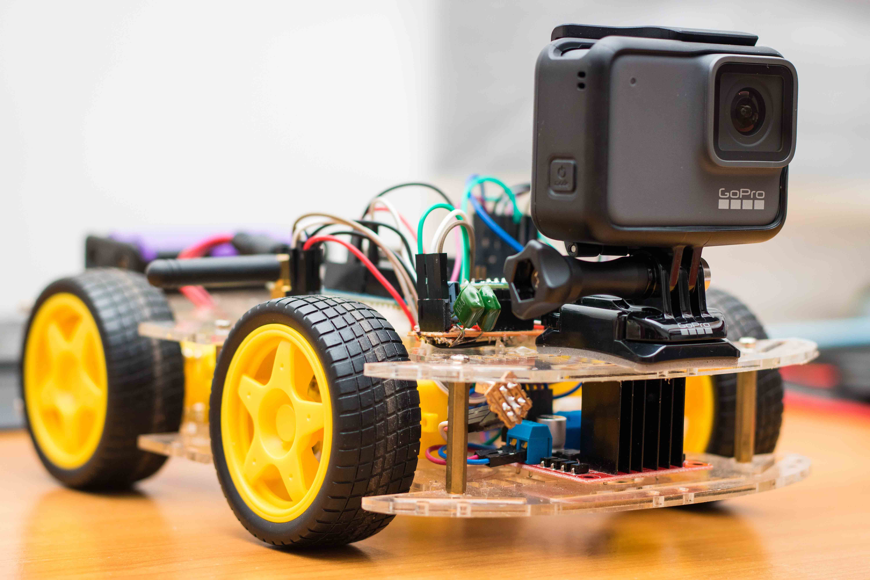

### 2.2.2 Business Objectives

* Robot can be entered in a small space
* Measuring the incident type
* Device handle by the main user
* Can get photos and videos of the current situation
* Incident update to the database
* Identify the Temperature Level
* Unlike other remote devices the connection won’t be lose.

## 2.3 Project Objectives

1. Initial Background Analysis & Literature Review:

* Provide a real time service to the customer
* Maintaining a full detailed database about incidents
* To analyse potential development technologies and deployment solutions
* To implement the new Arduino system in line with new processes and procedures
* Remote Controlling facility

1. Student learning undertaken and Requirements:

* Trouble shooting with the errors that will occur in Arduino tools
* Fixing the Arduino Robot without any mistakes
* Knowledge about ASP.net
* Coding in Arduino IDE
* Knowledge in new software components and applications
* Handling new Arduino components
* Action Camera settings and Tools

1. High-level design:

* The Web can produce a user friendly interface and an understandable approach for the handler
* Safe Robot
* Robot can handle by the joystick module
* The project should produce Class Diagram
* The project should produce Use Case Diagram

1. Development activities:

* The project should produce a more specific set of requirements after each iteration
* The project should design the system in such a way that satisfies the requirements
* The project should implement the system in such a way that satisfies the design
* The project should test the implementation to ensure that it satisfies the design and the requirements

1. Testing

* The project should test with randomly selected people to ensure that it satisfies all design, requirement and business objectives.

1. User Documentation

* The project will create an understandable document.

1. Academic documentation:

* The project should produce academic material including PID, Interim Report 1 | 2, Poster and Final Report.

## 2.4 Deliverable Parts

### 2.4.1 Arduino Robot

This is the main deliverable part of this project. Through the Arduino robot we can estimate the damage occurred in particular incident. That means we can capture the pictures and videos through the action camera. There is a temperature sensor in the robot.

So we can calculate the temperature level in an incident. That will help us to pre identify the temperature measurements.

### 2.4.2 Temperature Displayer

The captured temperature details will pass to the temperature displayer. To run this, we need WAMP server. Also we need to specify the current Wi-Fi connection name, password and ip address in network interface IDE.

### 2.4.3 Web Application

Final Deliverable thing is the web page. That include all the photos and videos that captured using the robot. Authorized user can log into the system. So he/she can update, view and delete the records. Also by using the web we can send an email to the rescue teams about the current incident and ask them for the help for the injured people. All the data will store in the MSSQL Database.

# 3.0 Method of Approach

## 3.1 Design and Development Plan

## 3.2 Product Produced and Product Quality

**Components of the robot:**

* Arduino Uno Board

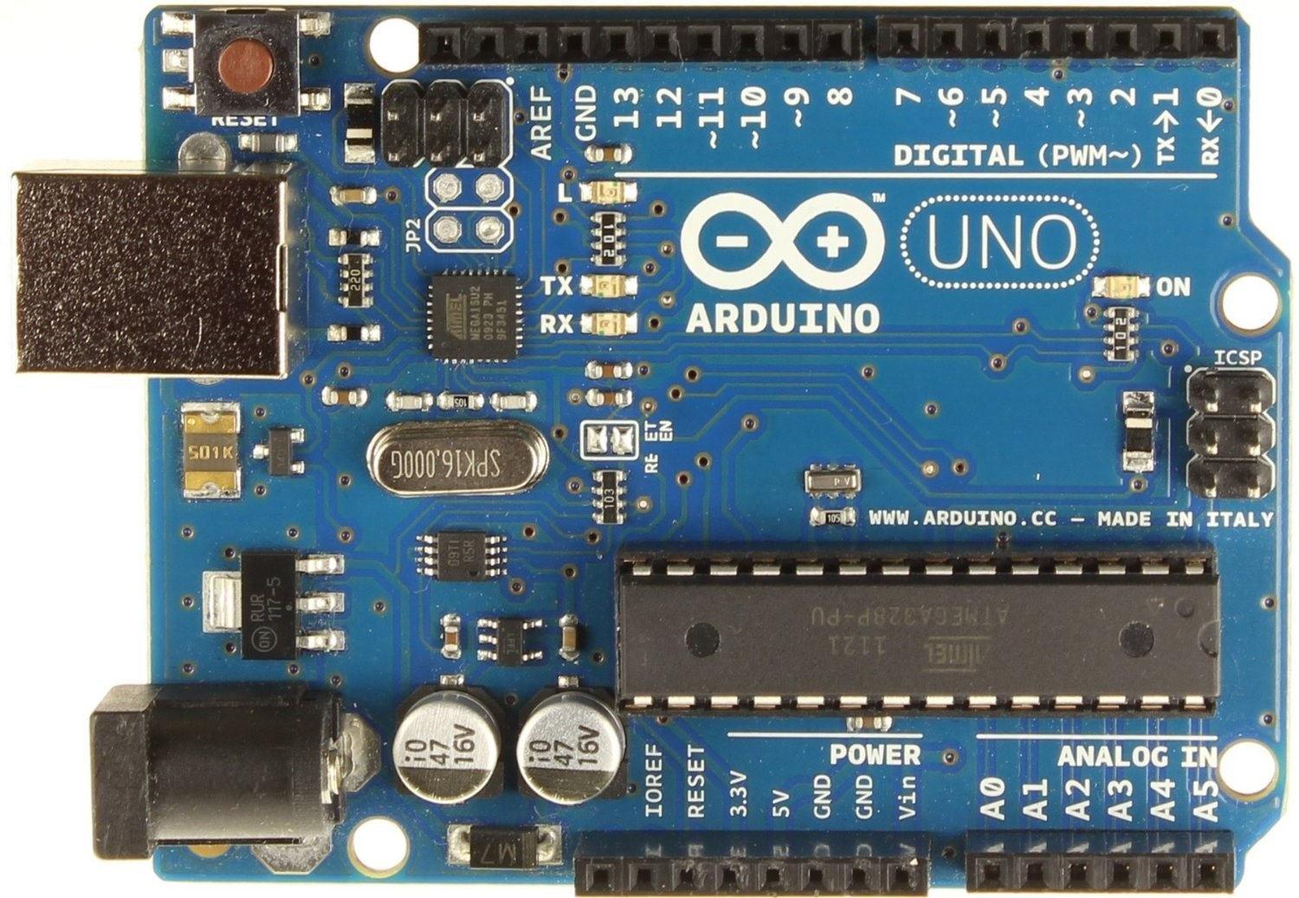

* HC -12 module

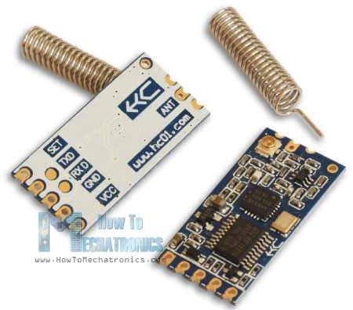

(Dejan, n.d.)

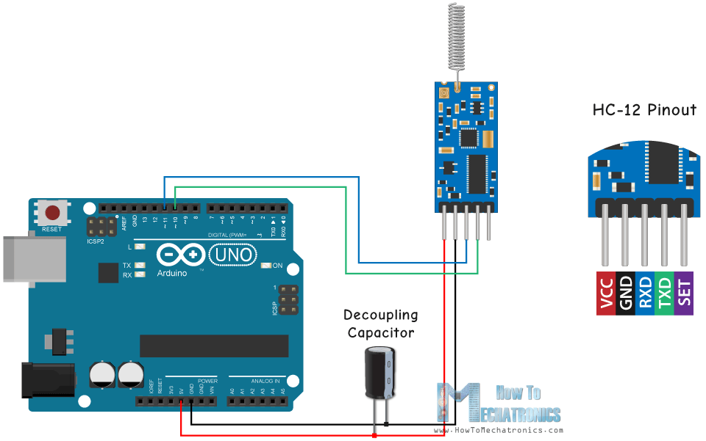

(Dejan, n.d.)

* L298N Motor Driver



(Pelayo, 2018)



(Pelayo, 2018)

* Arduino Nano Board

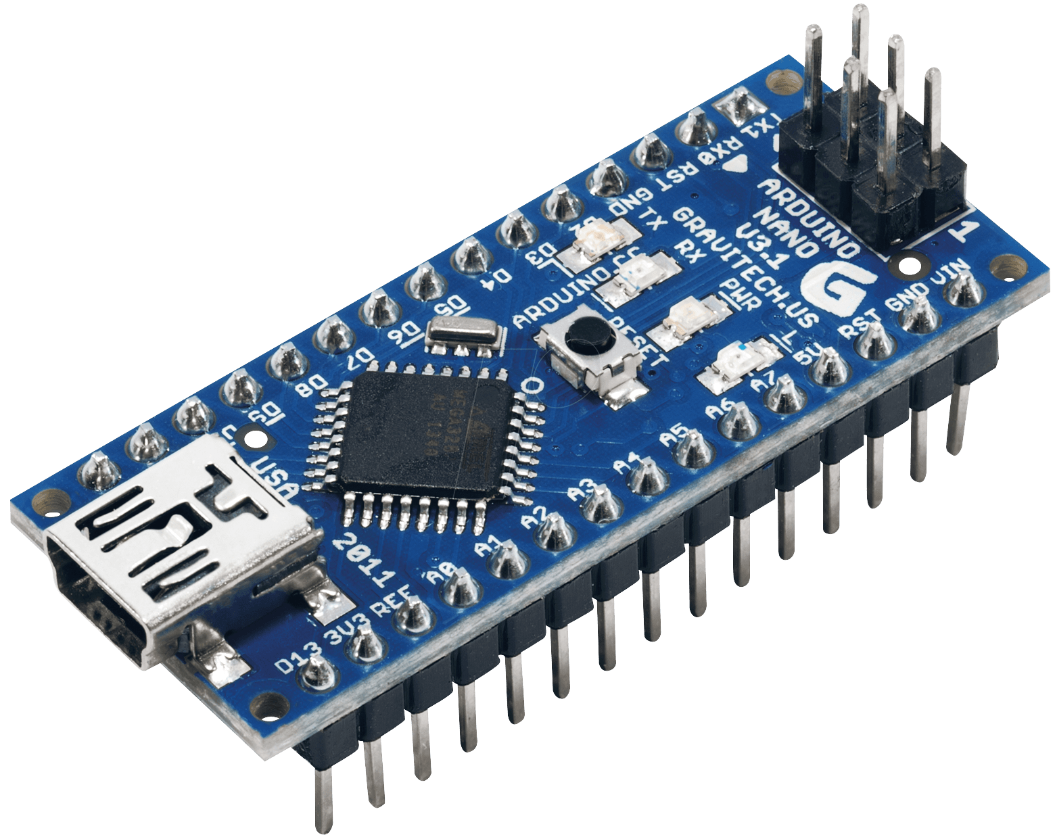

**picture of the Arduino Equipment**

* XY Joystick Module
* 18650 Battery
* 4*4 Car Body
* 433 MHz Antenna
* 10K NTC Thermistor

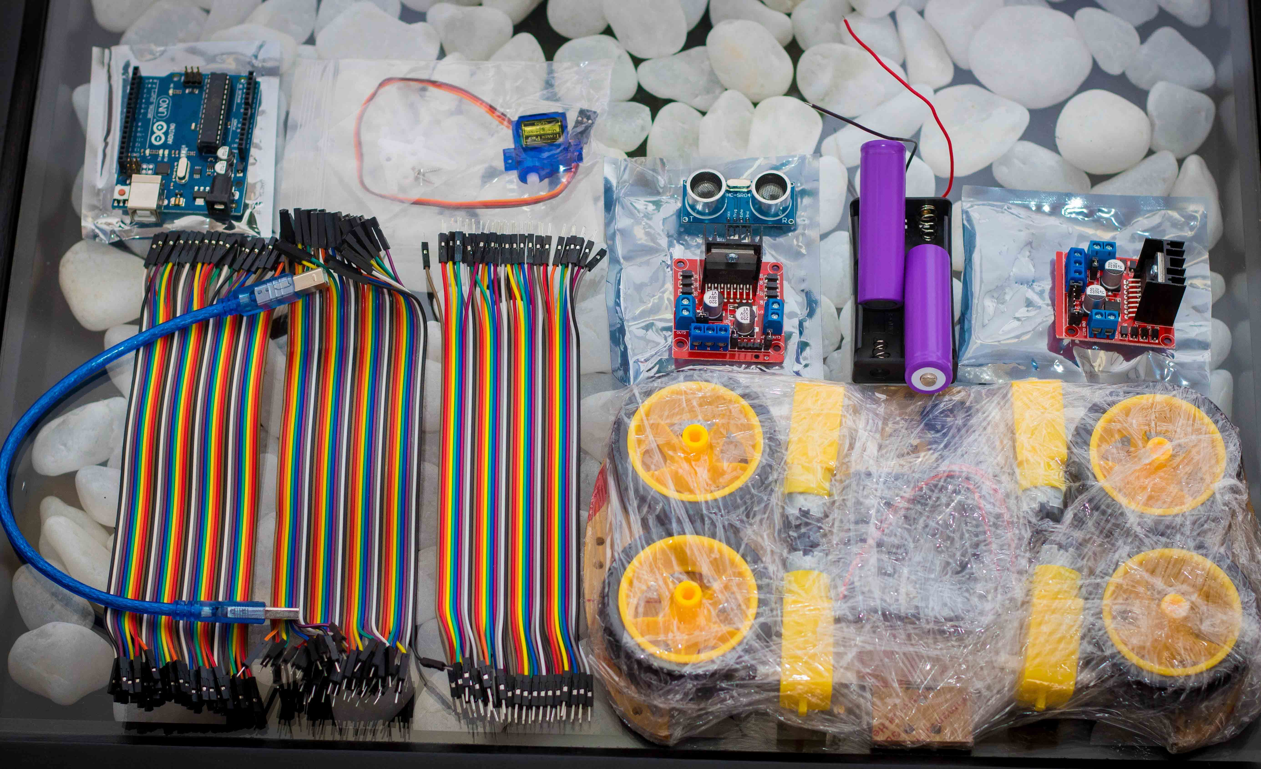

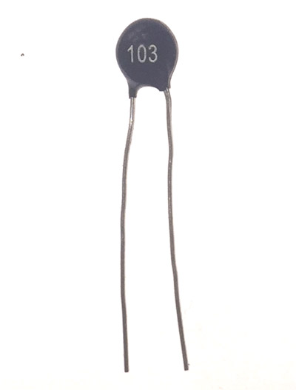

(htt)

* ESP-8266 Board and Adapter

**18650 Battery pair**

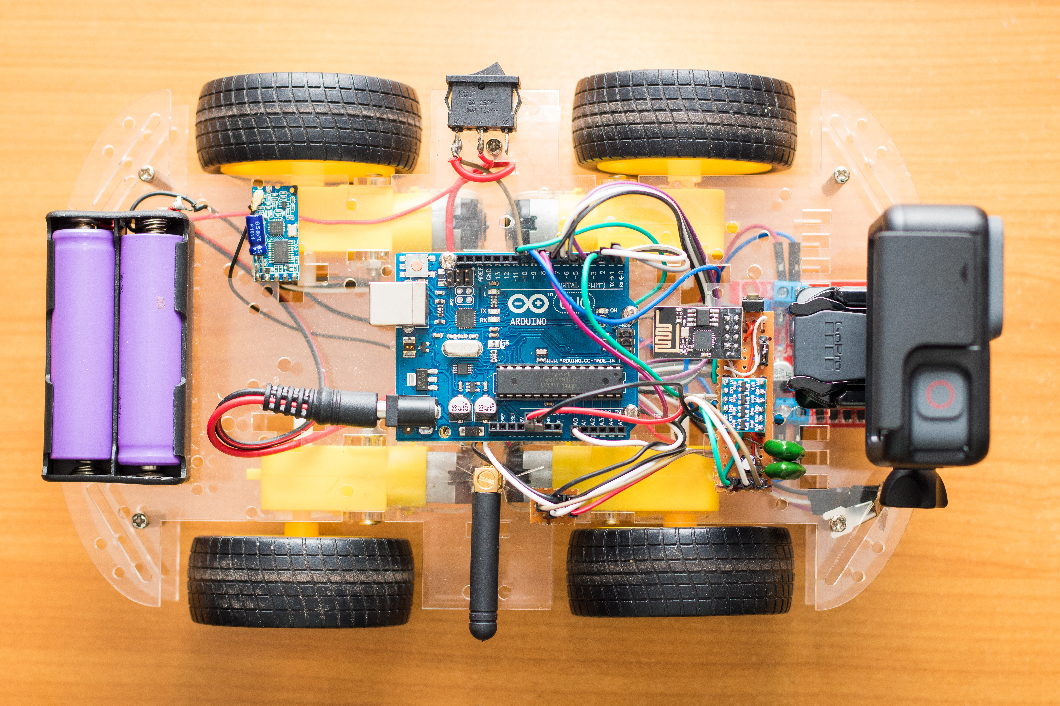

**Power Button**

**L298N Motor Drive**

**ESP-8266 Board**

**433MHz Antenna**

**10K NTC Thermistor**

**HC-12 Module**

**Arduino Uno Board**

**GoPro Action Camera**

* Detailed Robot

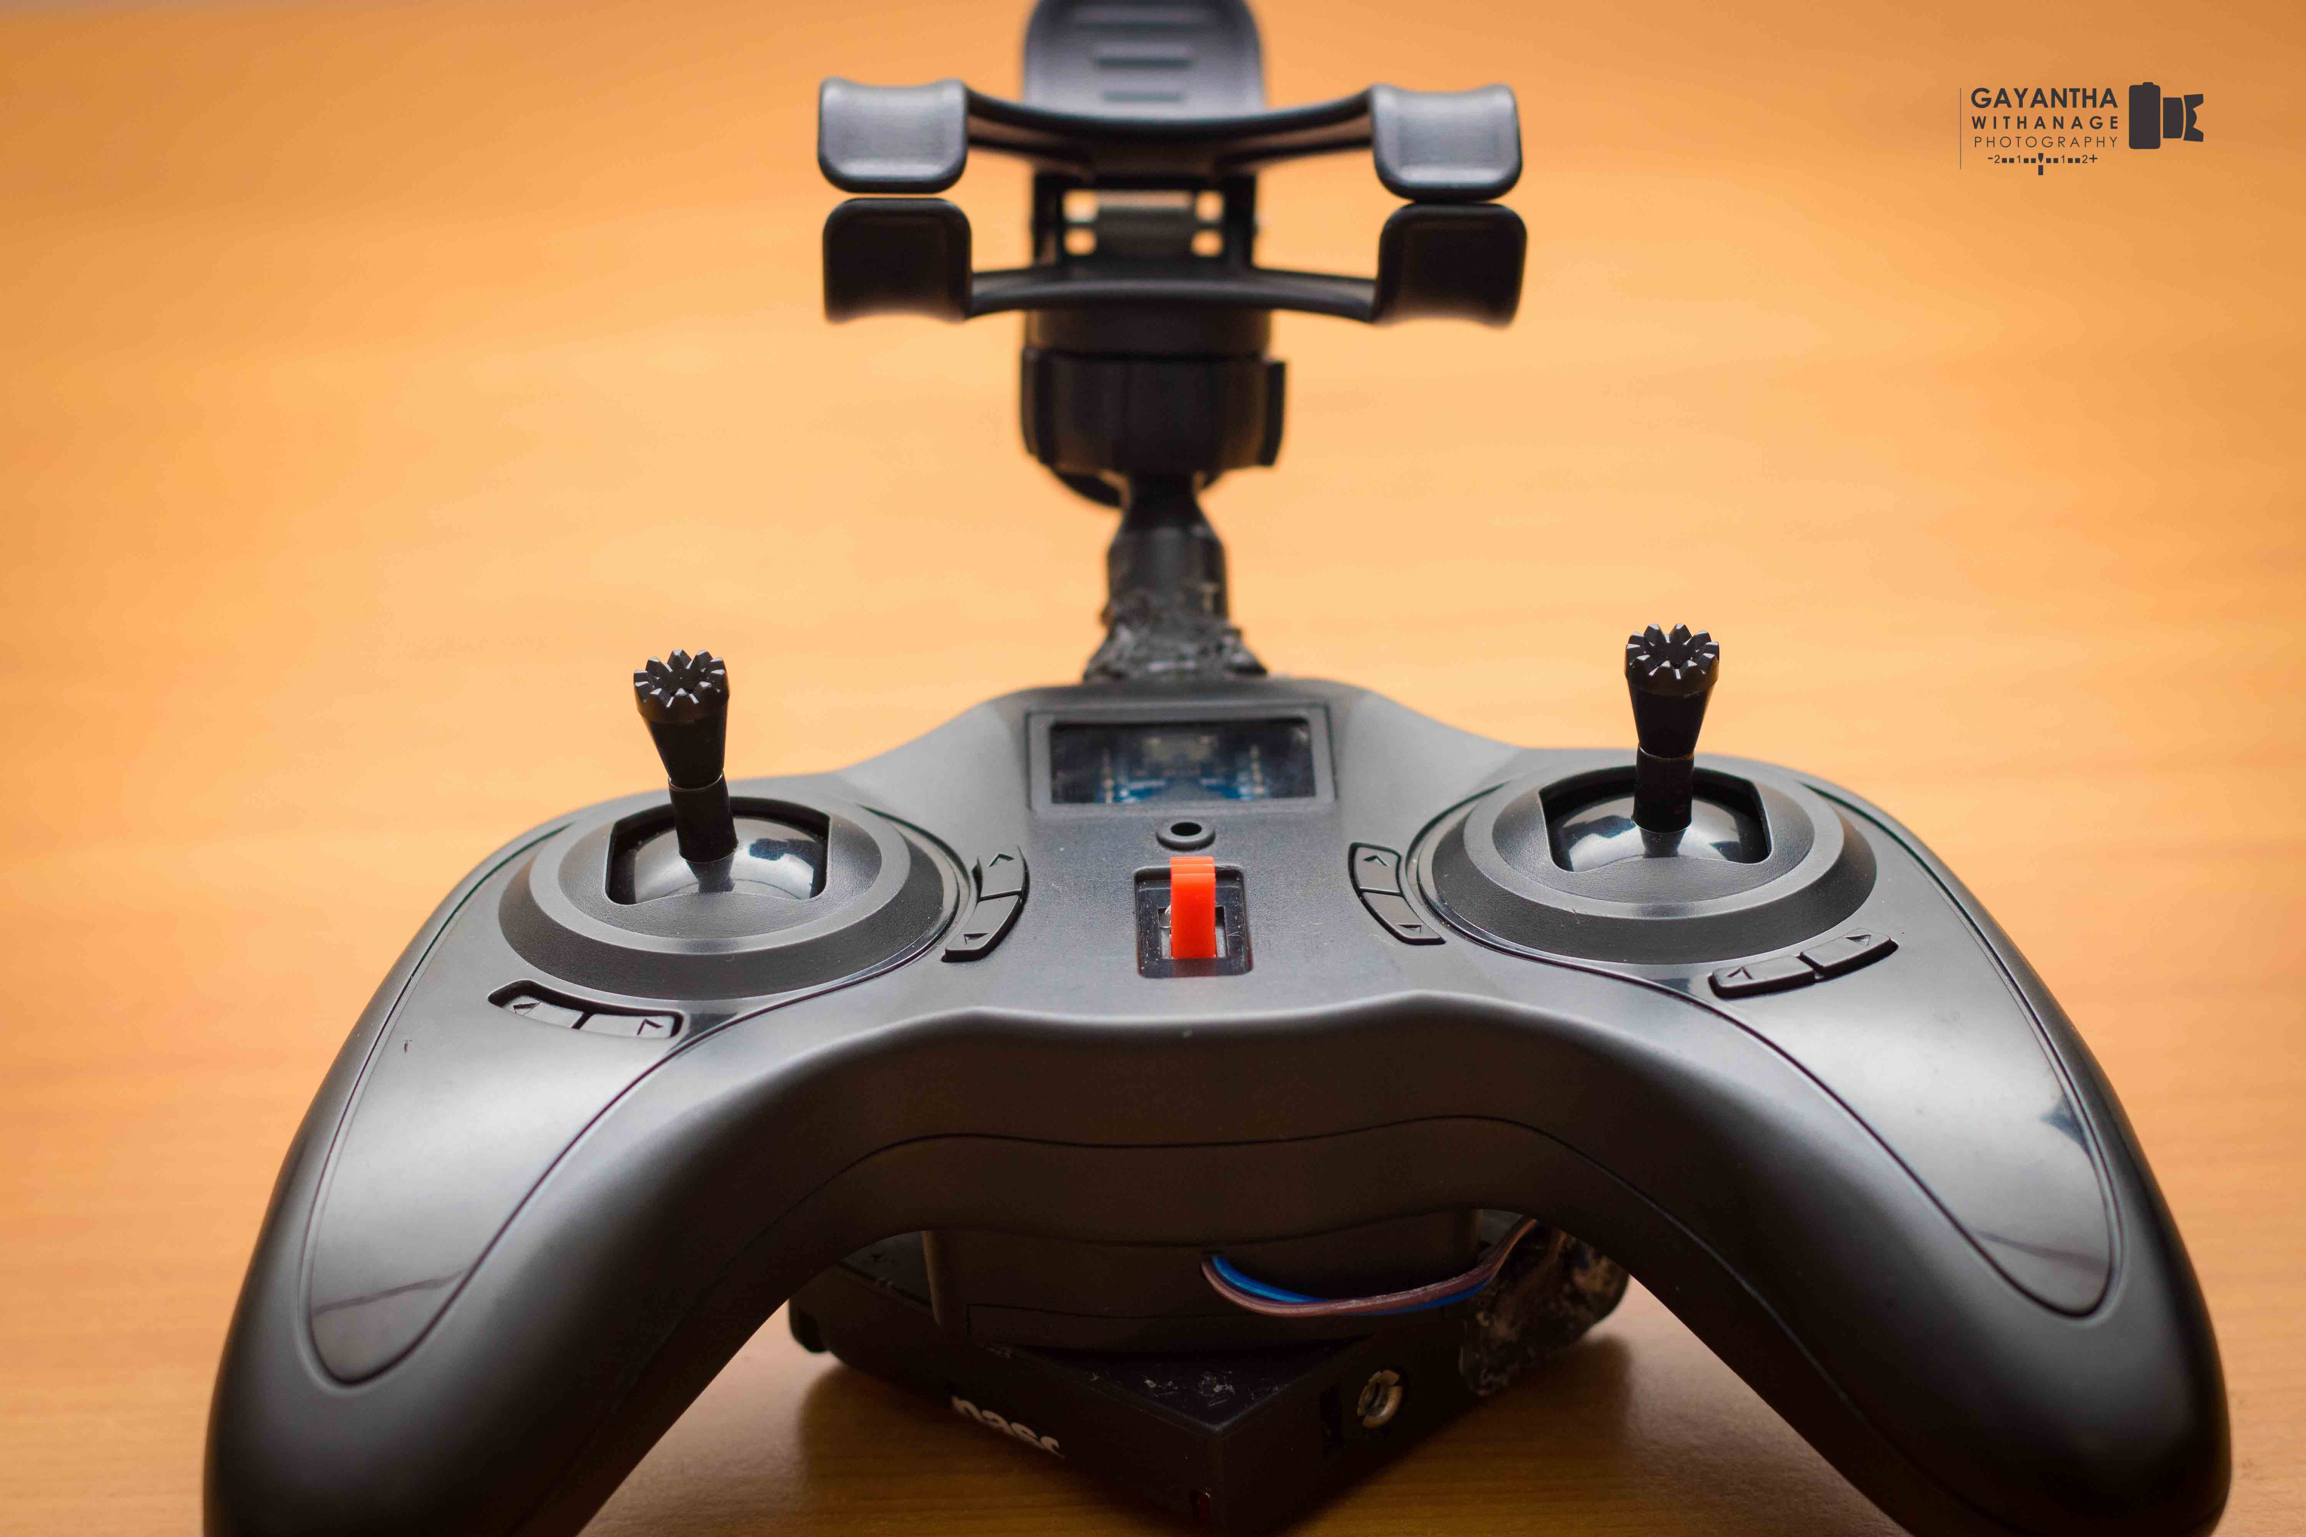

**Arduino Nano Board**

**Left | Right**

**Forward | Backward**

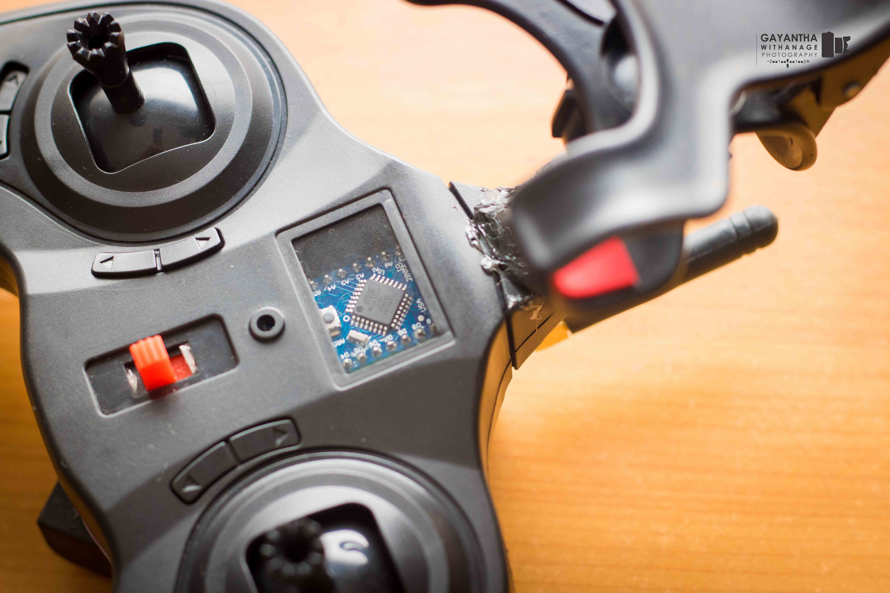

**Antenna**

**Switch**

### 3.2.1 Process of the Arduino Equipment

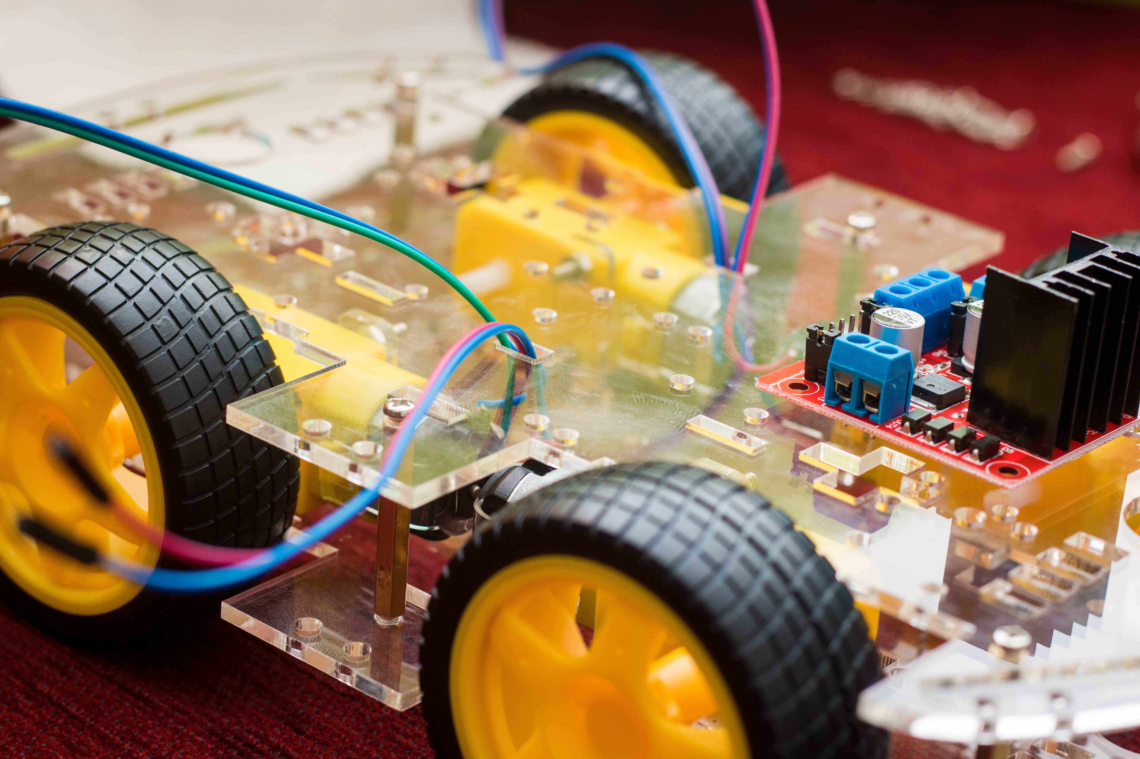The 18650 Batteries supply the power for Arduino board and Motor Drive. The DC motors power supply by the Motor Drive (Out 1 – Out4).

* Connecting to the Motor Drive.

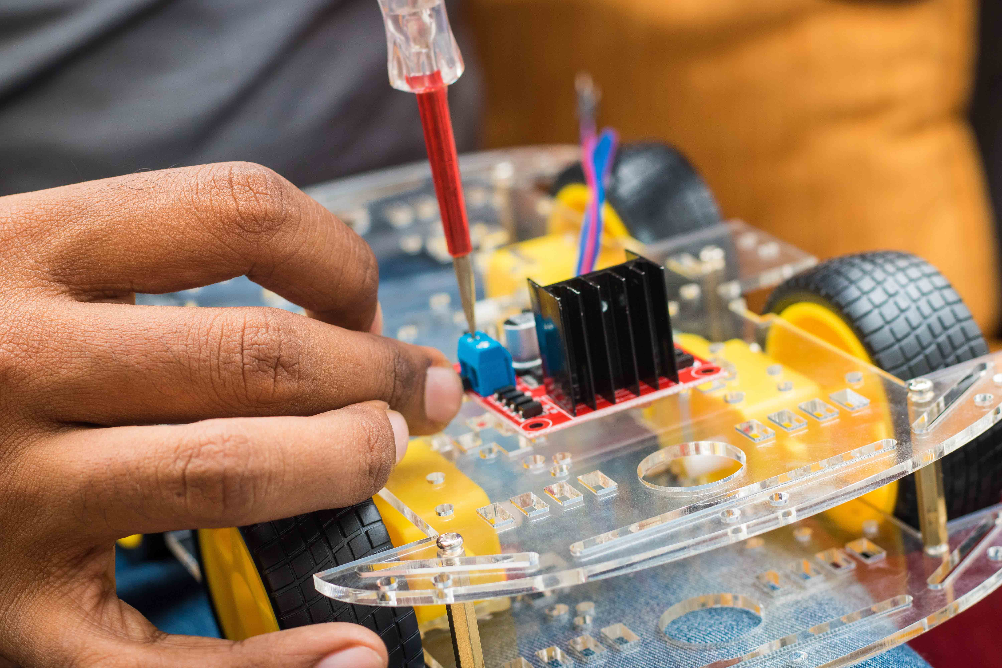

There are 5 pins on HC-12 module.

* + VCC – Voltage in (+)
  + GND – Ground (-)

Through the Uno board the power will supply for the HC-12 module.

Tx and Rx ports are in Uno board.

* Tx – Transmitter – (1)
* Rx – Receiver – (0)

433mHz antenna connected in to SMA connection in HC-12 module. Unlike other systems by using this antenna we can control this robot within 1.8km. There are two 22uf capacitors include to HC-12 module. By using the capacitors, we can reduce the connection lost errors. HC-12 module will capture the signal generating in the remote controller. After that signal will process and that will go for the motor drive.

Processing signal

Remote Controlling signal

HC-12 Module

Motor Drive

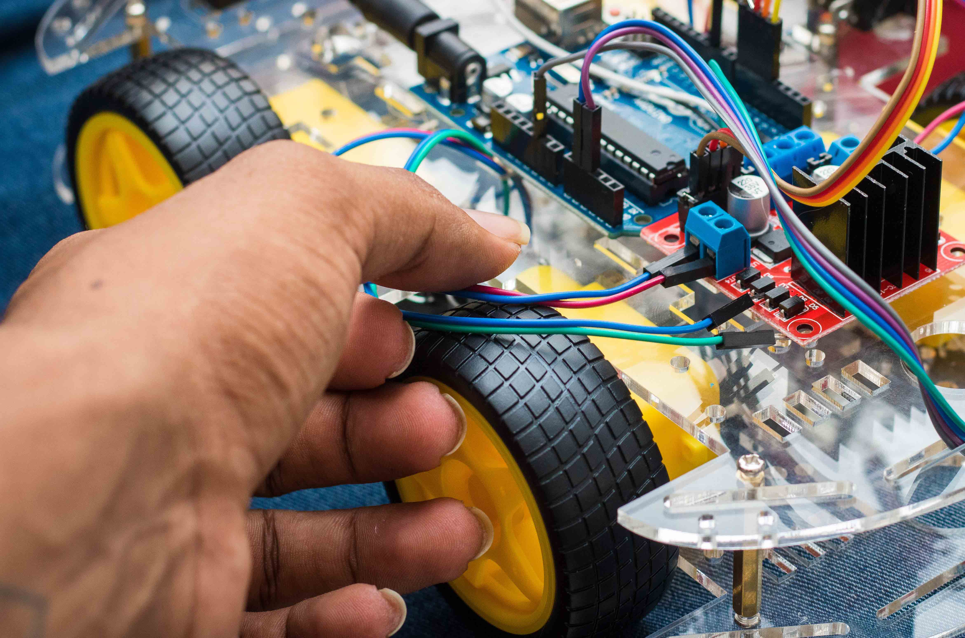

Signal Receiver

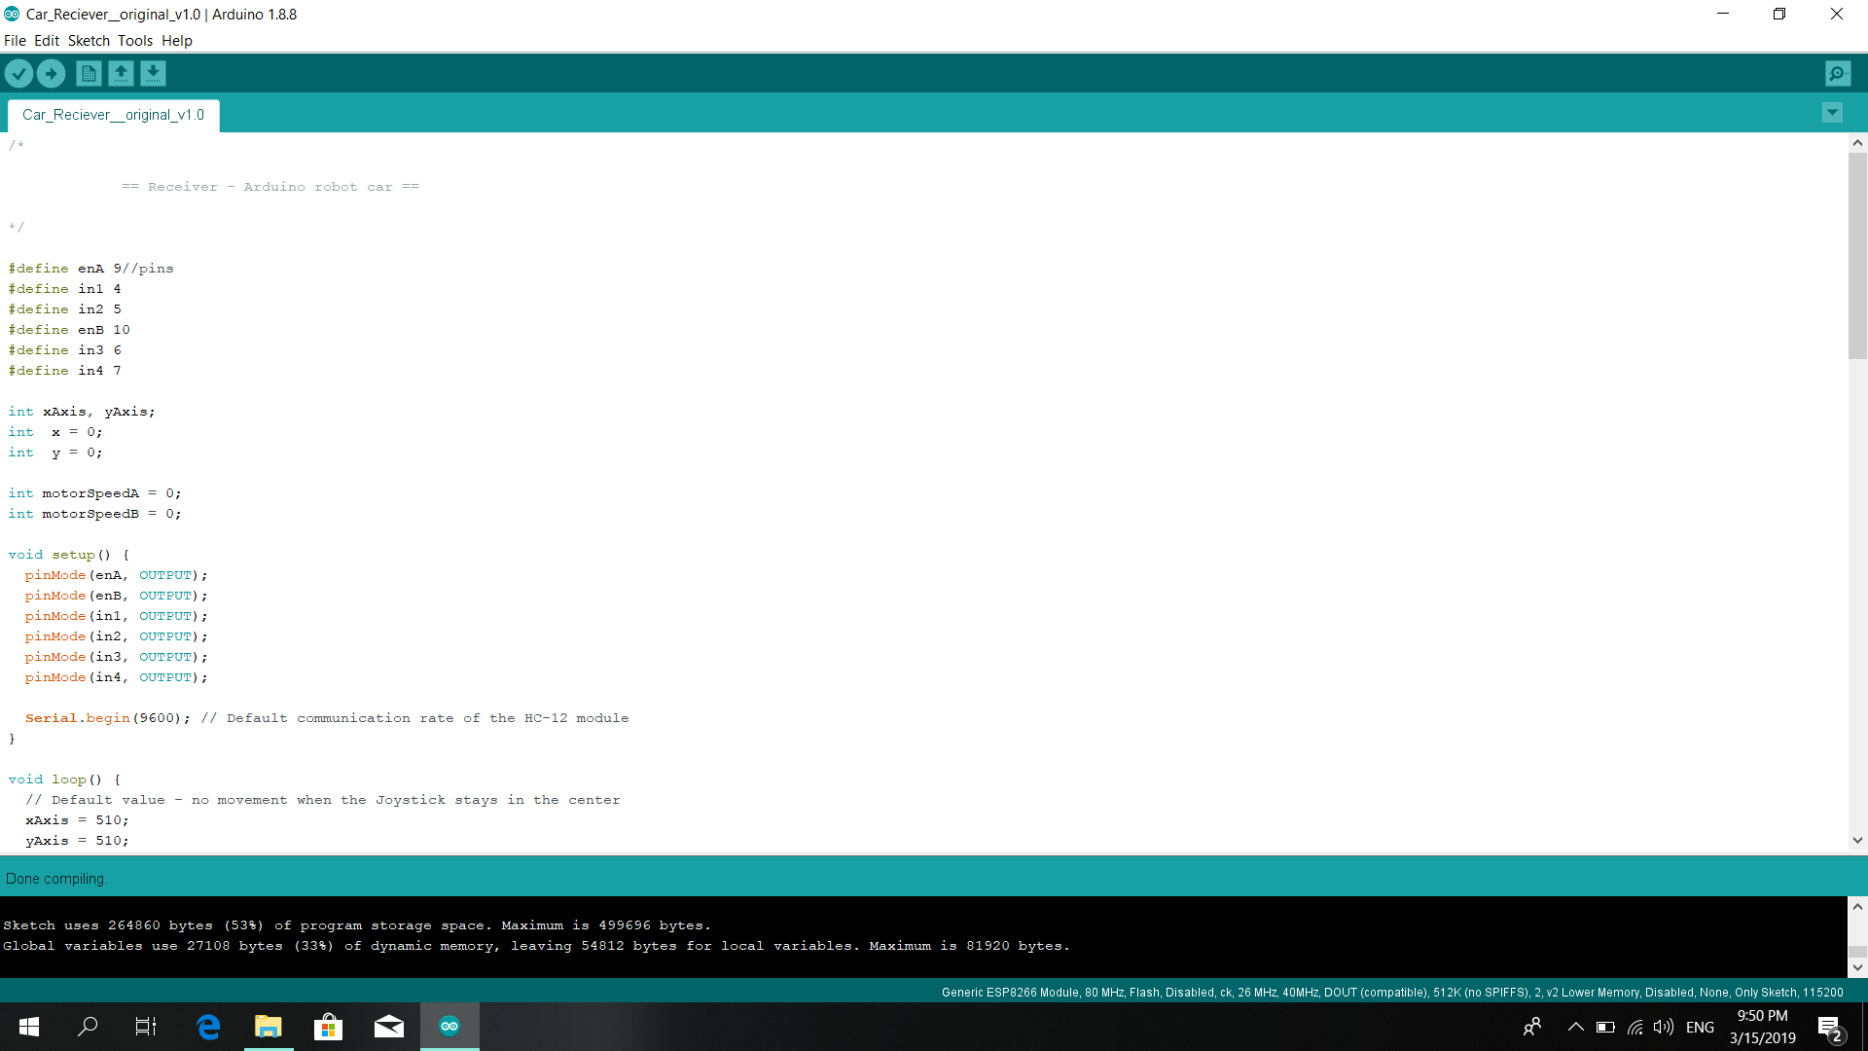

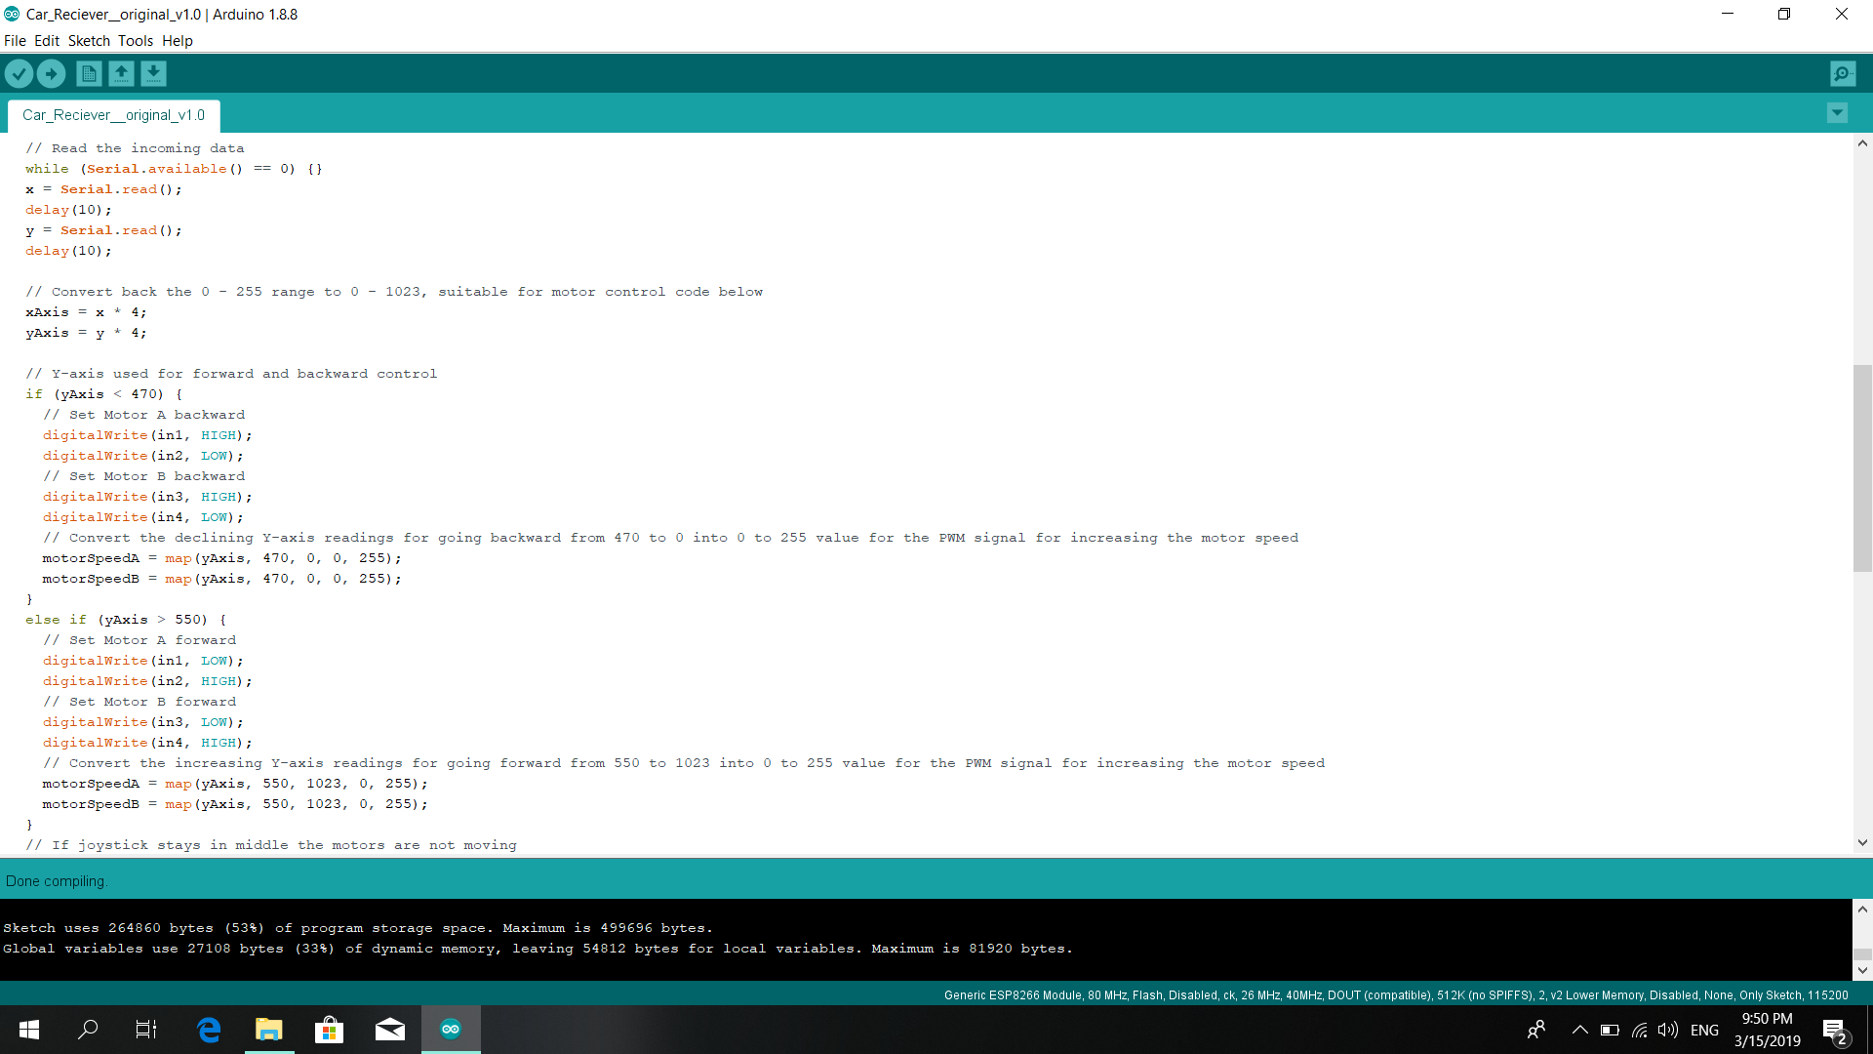

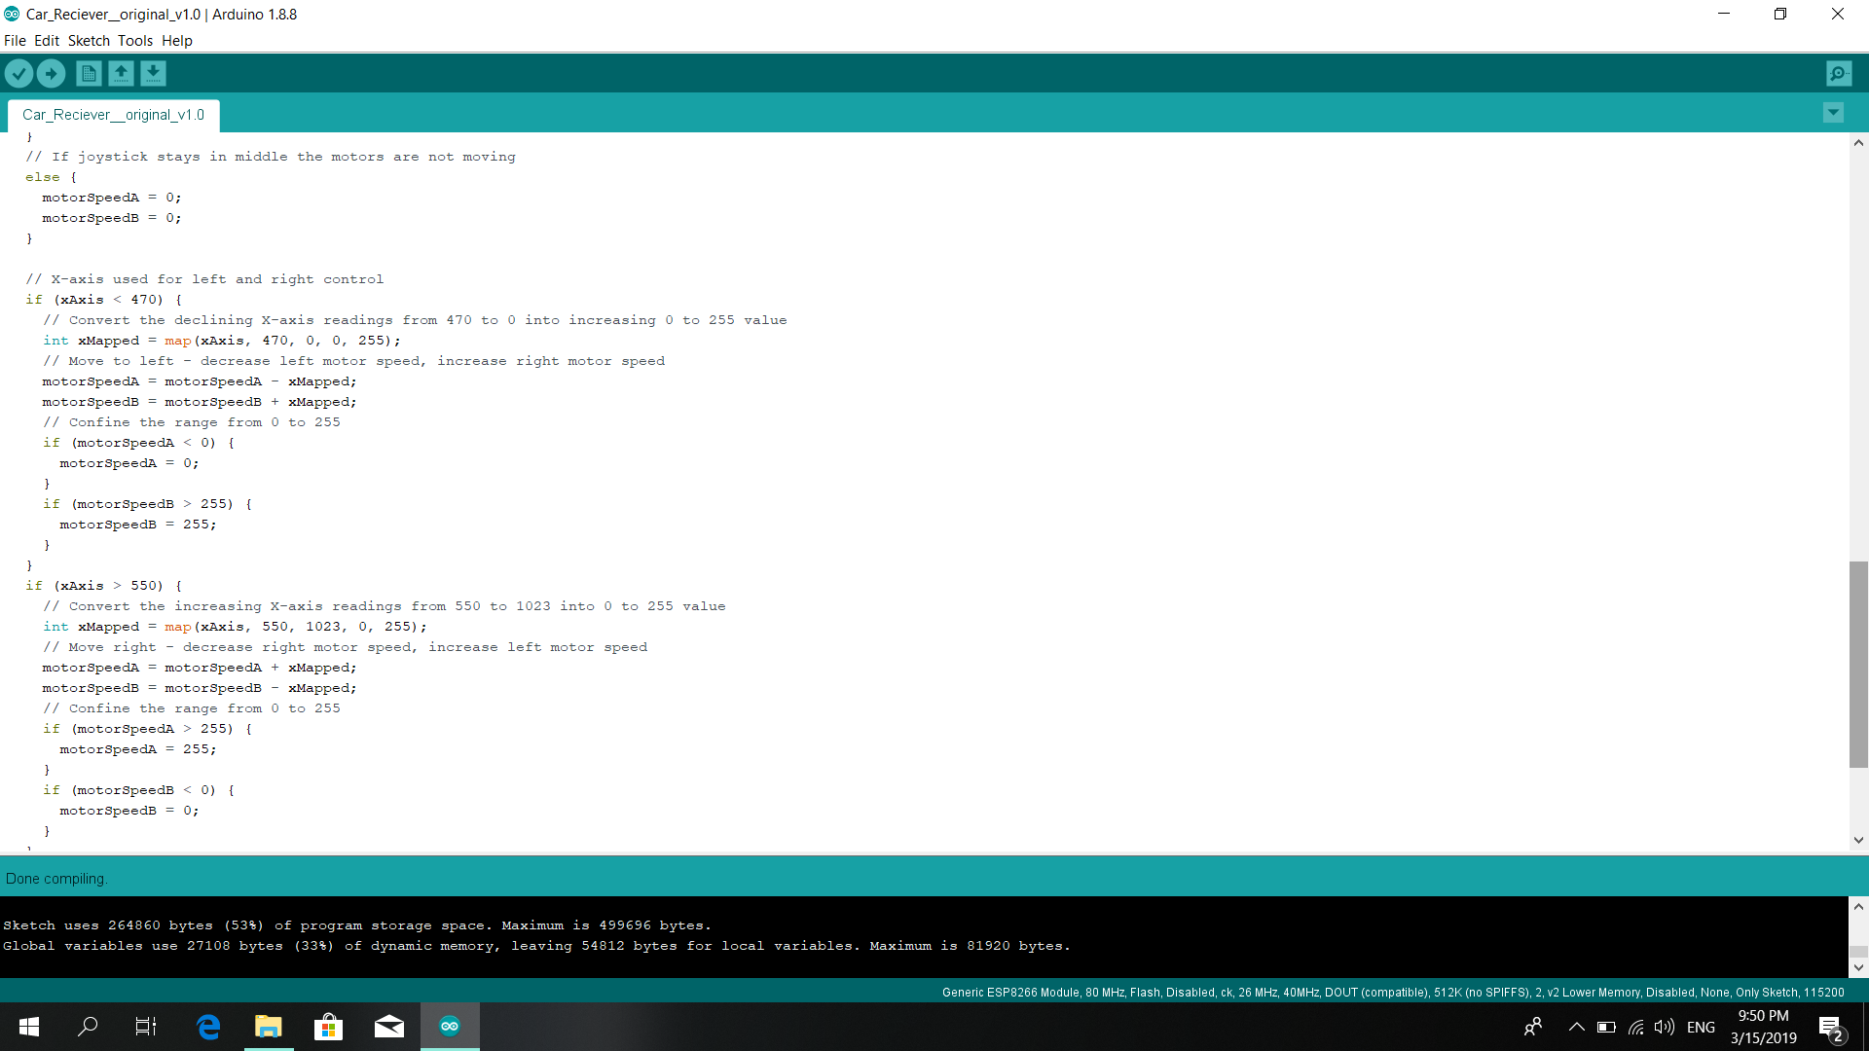

The Arduino Nano board supply power to the joystick module. (5V out pin)

* Analog pin A0 – Joystick (Left | Right)
* Analog pin A1 – joystick (Back | Forward)

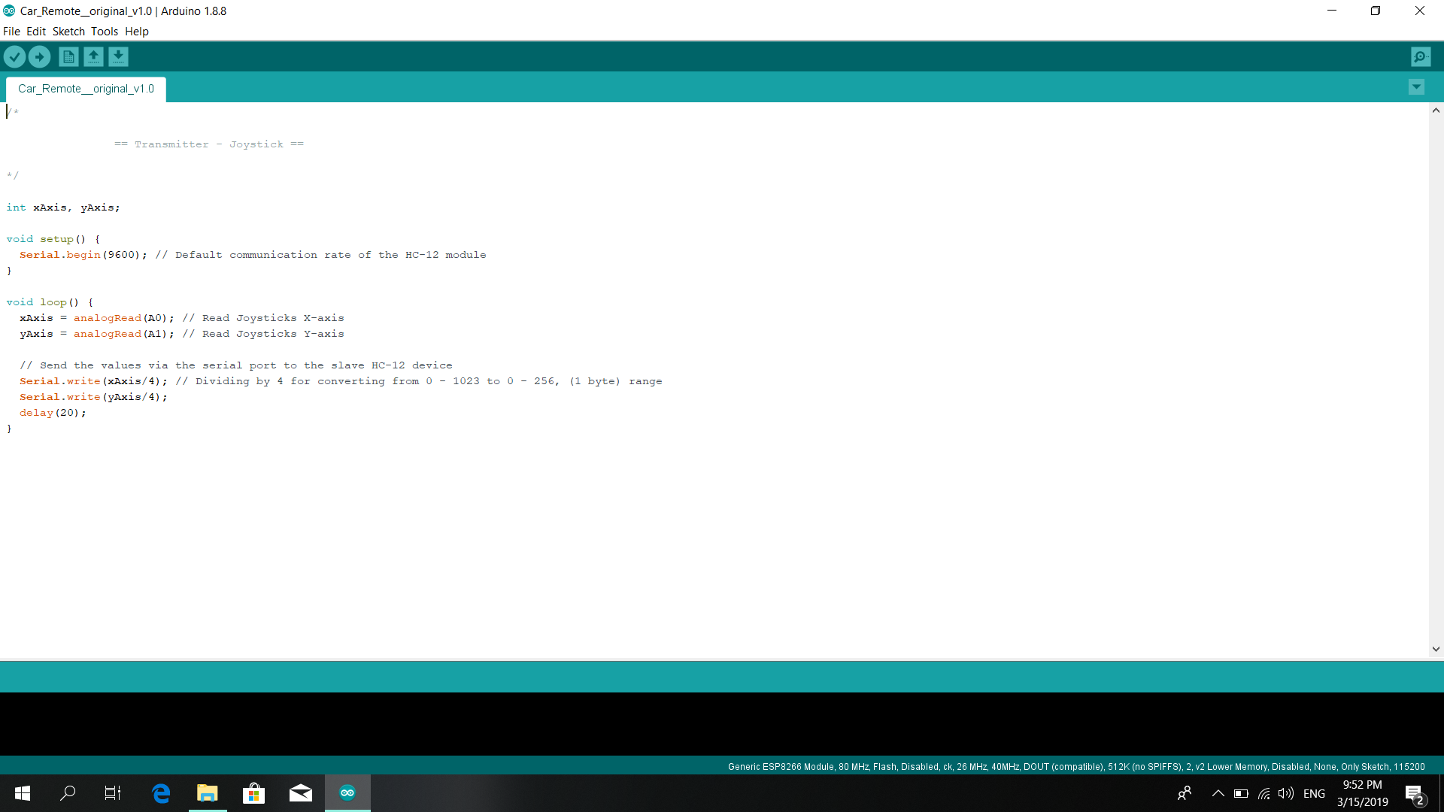

C language is used to code in Arduino IDE.

### 3.2.2 Configuration of the Temperature sensor

The Uno board collect the data from the temperature sensor and the processed data will send to the network interface. The communication between the Network interface and ESP8266 module are done by the serial protocol.

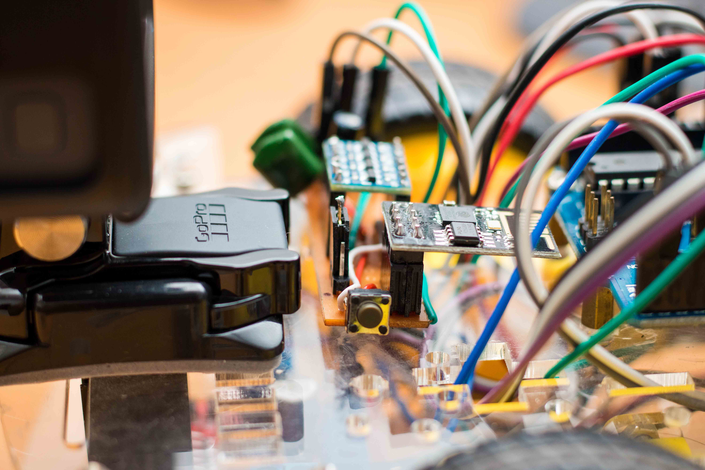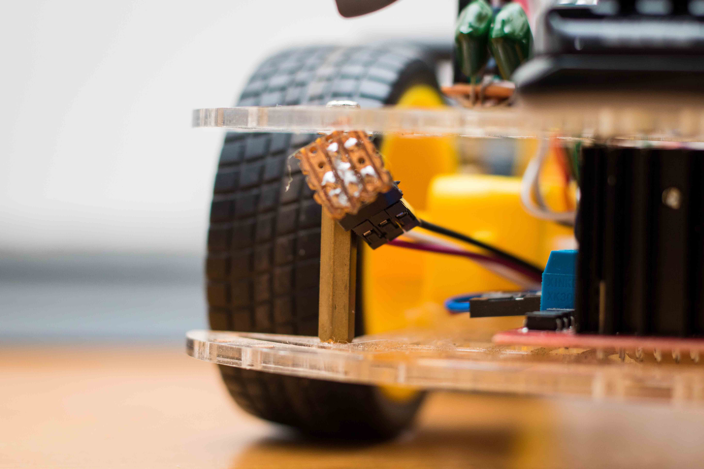

1. The 'rms' folder must be placed in www (if using WAMP server).

2. The MySQL database must be imported.

3. Credentials in PHP database connections must be changed accordingly.

4. The ESP8266 firmware must be re-flashed with the appropriate Wi-Fi credentials and server IP address.

5. The NTC sensor and ESP8266 must be connected to the main microcontroller (ATmega328P).

- The ESP8266 must be connected using a software serial line.

**Programming the ESP8266 module**

* Install the PL2303 (serial converter) driver (has to be installed every time the computer is restarted).

* When programming the ESP8266 module using the serial converter, switch off the car's power supply and make the connections as shown below.

* The programming mode jumper in the ESP8266 module has to be set to programming mode (has a black marking).

* When the Arduino IDE compiles the sketch and enters into the uploading phase, the ESP8266 module's reset button has to be momentarily pressed.

Serial Converter ESP8266

5V -------------> 5V (Red)- 2

GND -------------> GND (Brown) -1

TX -------------> RX (has a black marking) (Blue) -3

RX -------------> TX (Green) -4

* After successful programming, the programming mode jumper has to be set to normal mode.

* The ESP8266 module must be re-connected to the Arduino Uno as shown below.

Arduino Uno ESP8266

5V (White) -------------> 5V

GND (Brown) -------------> GND

Pin 3 (Green) -------------> RX (has a black marking)

Temperature sensor

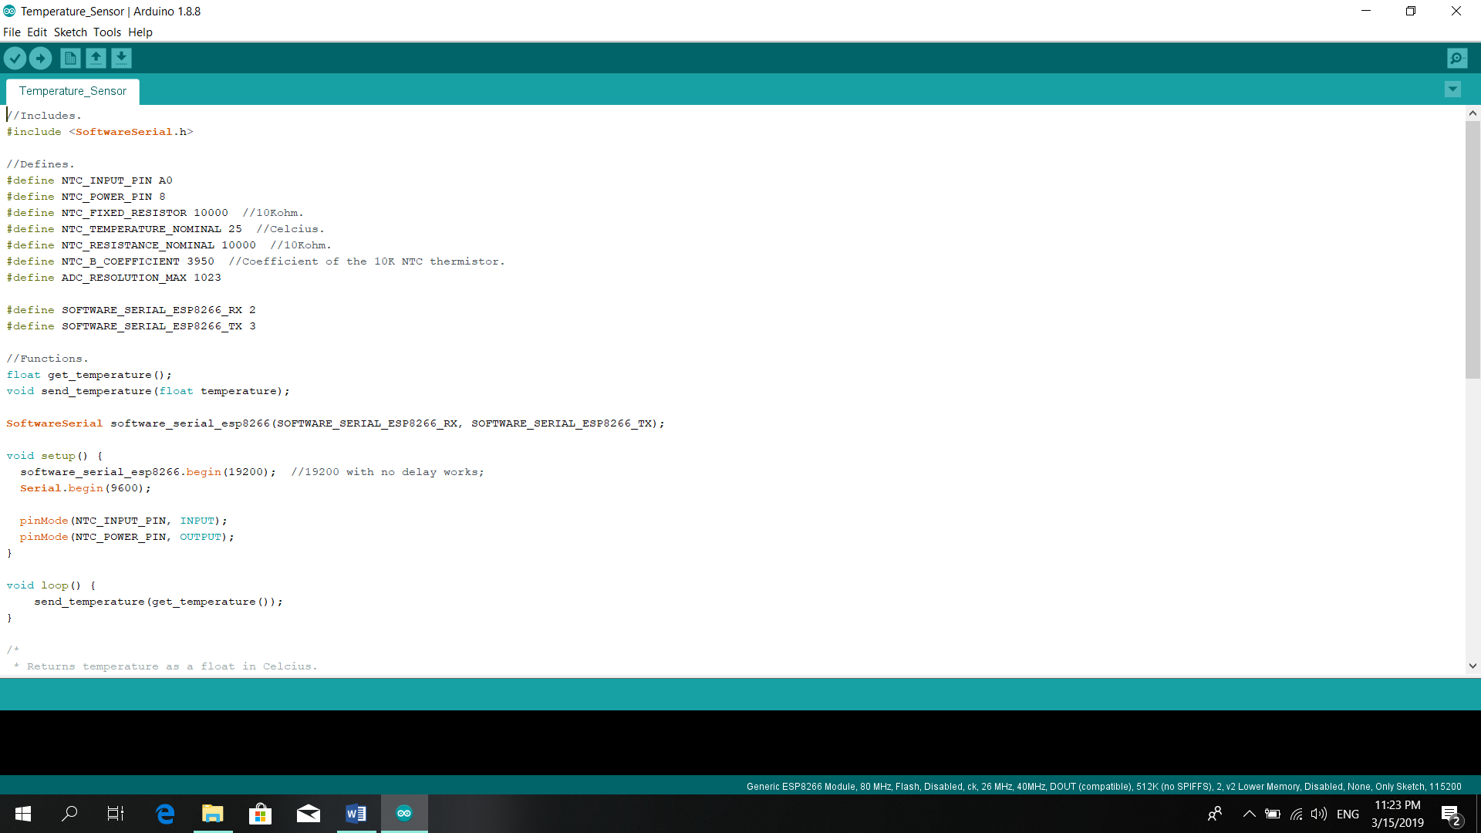

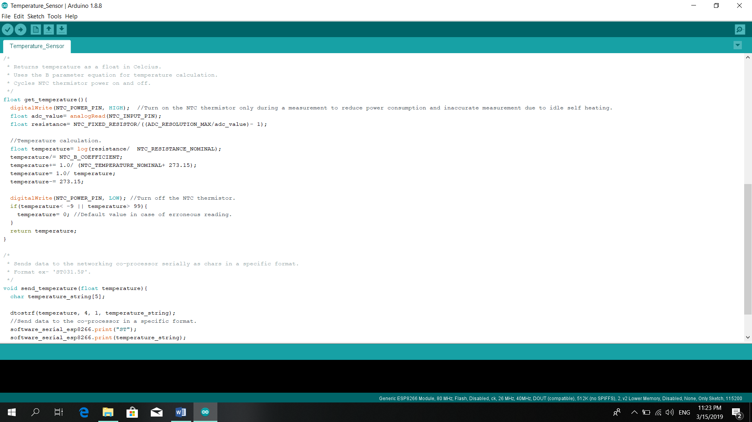

Network Interface

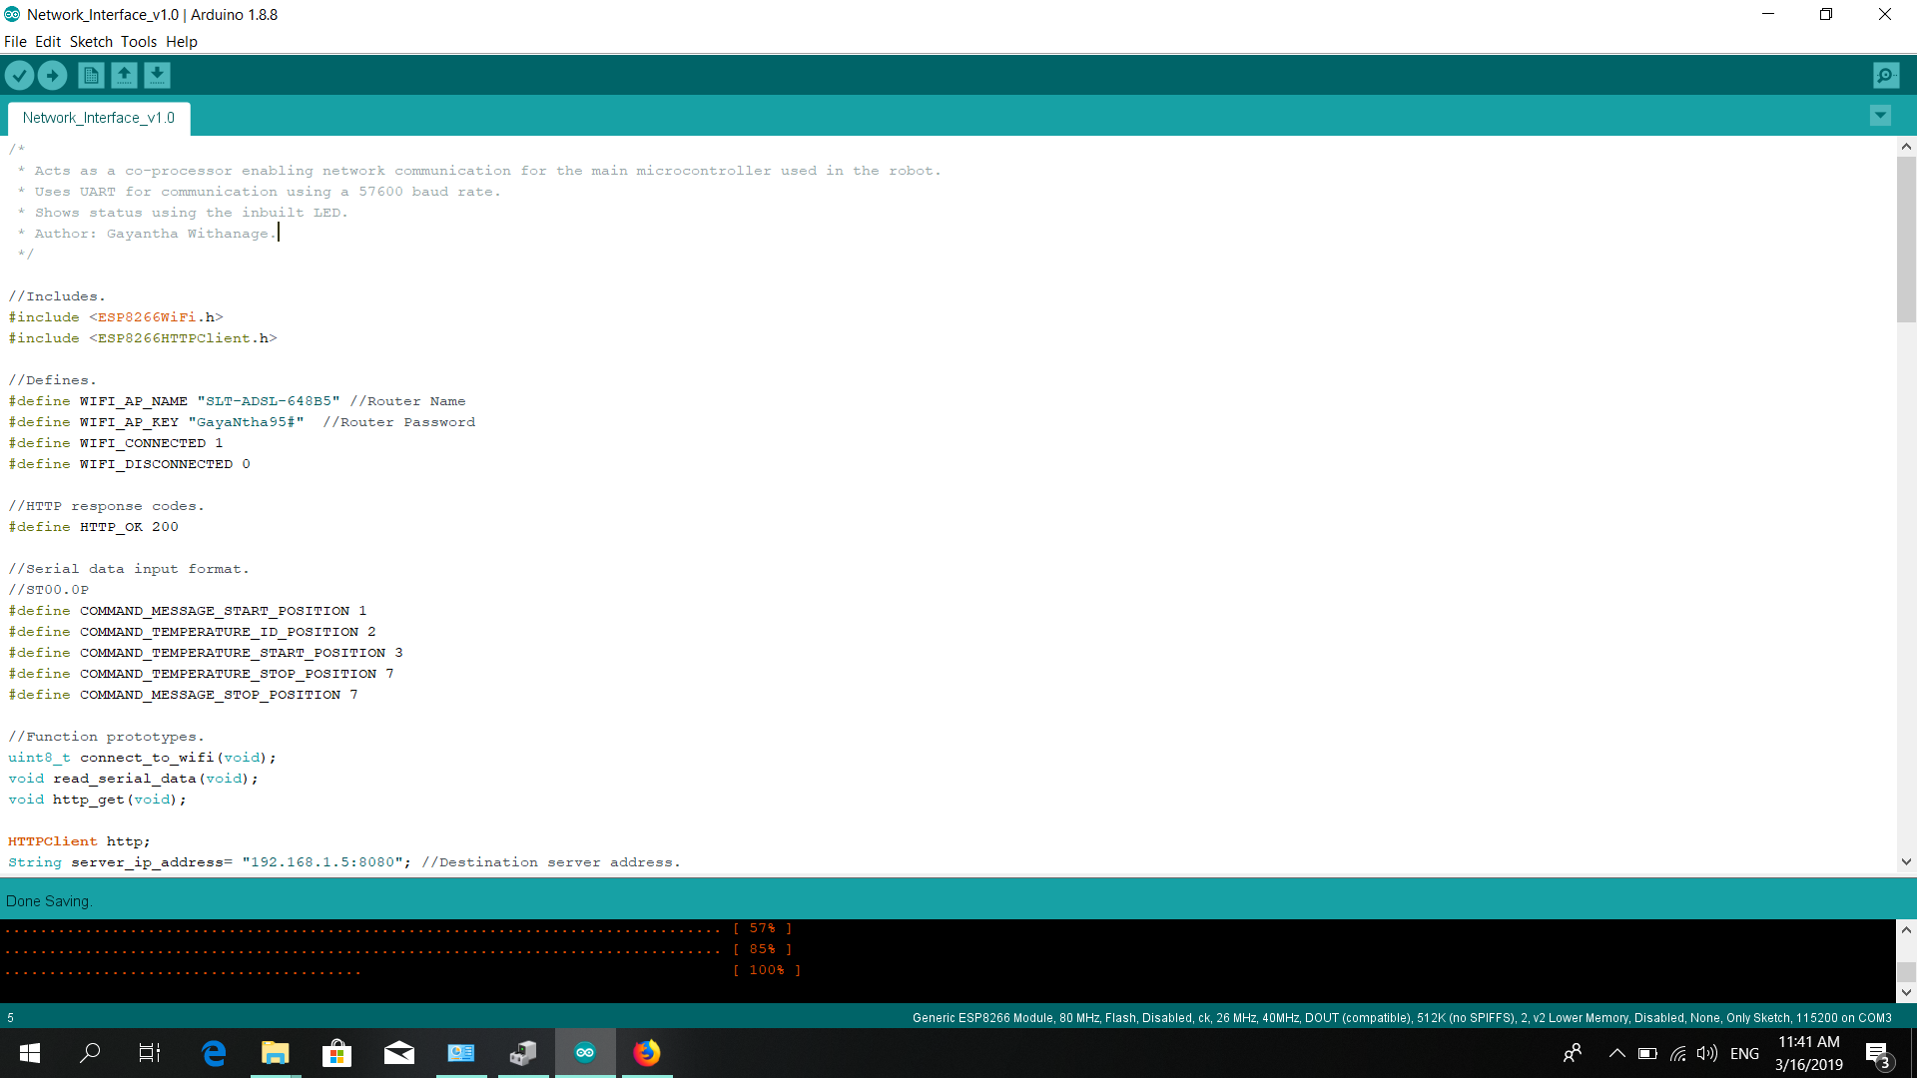

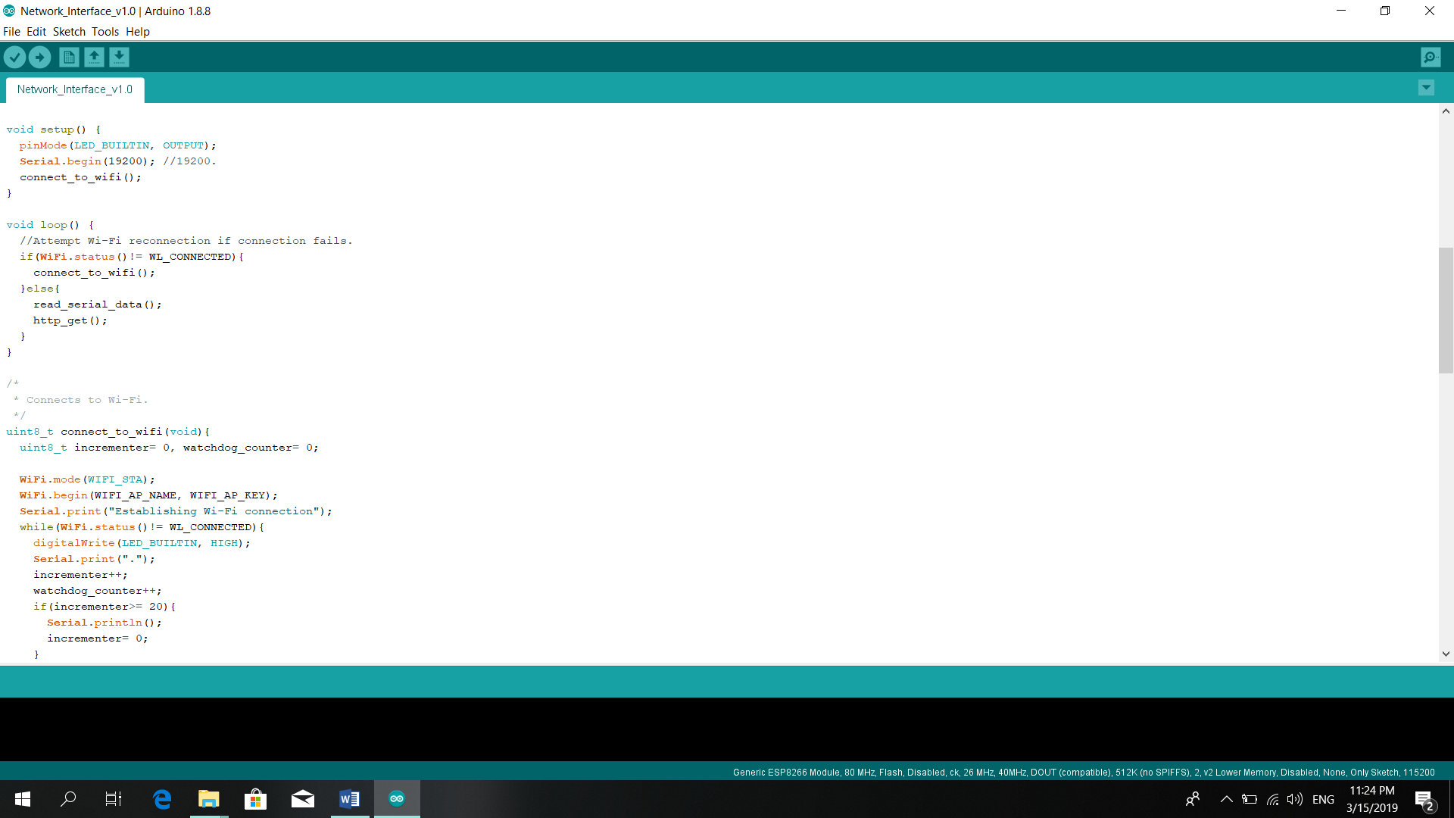

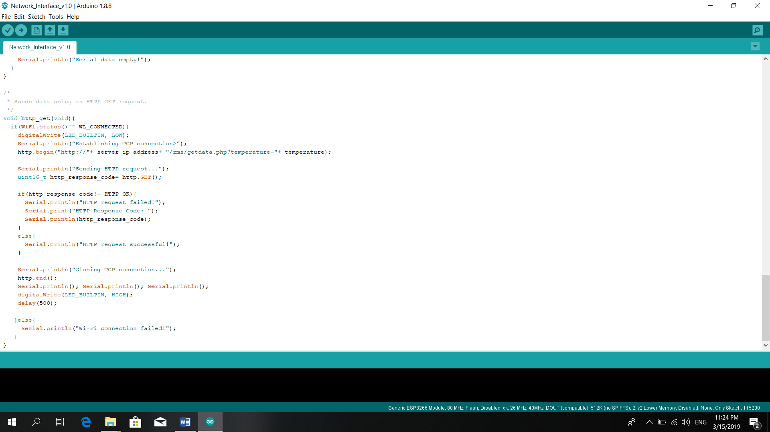

* Requesting – Temperature

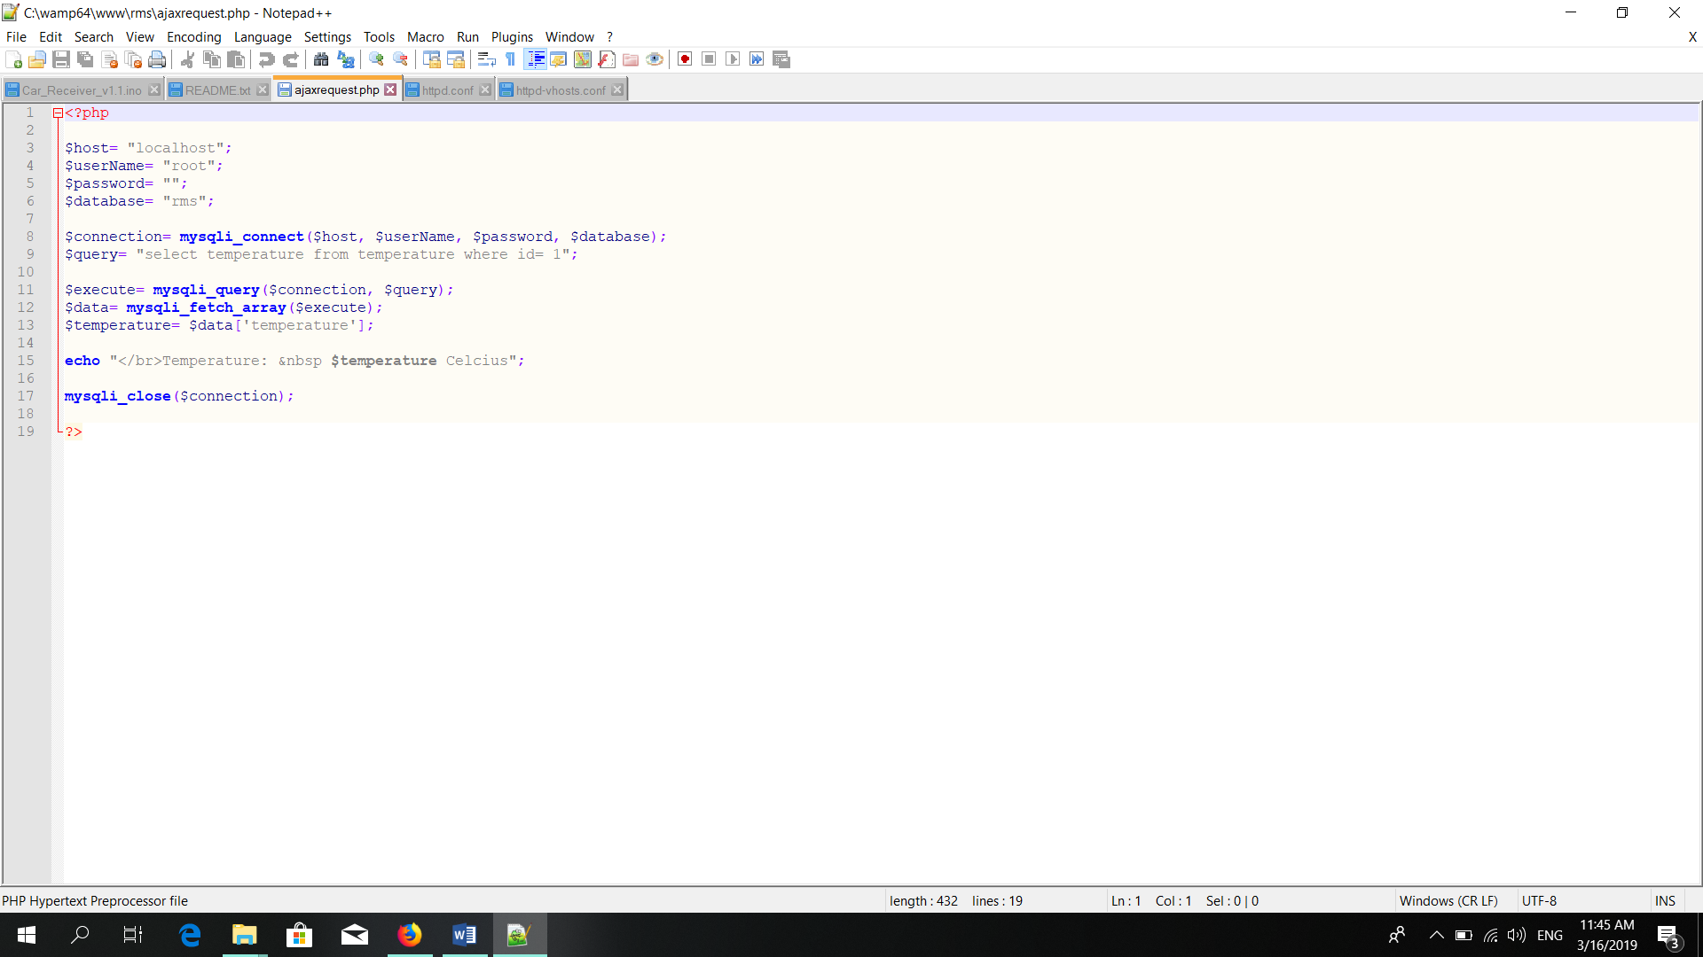

* Get Data

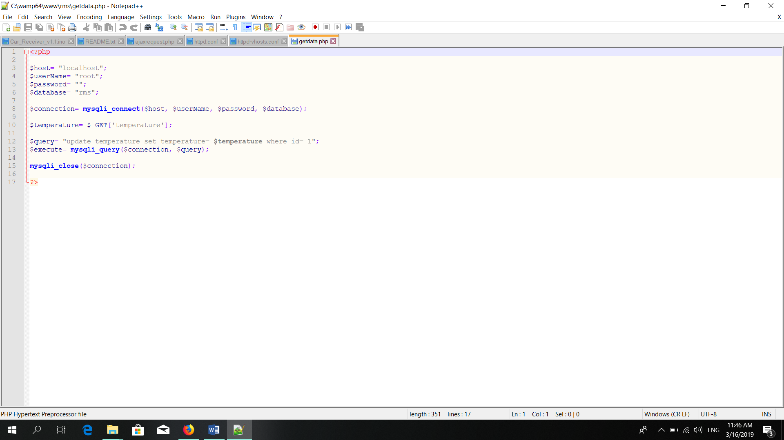

* 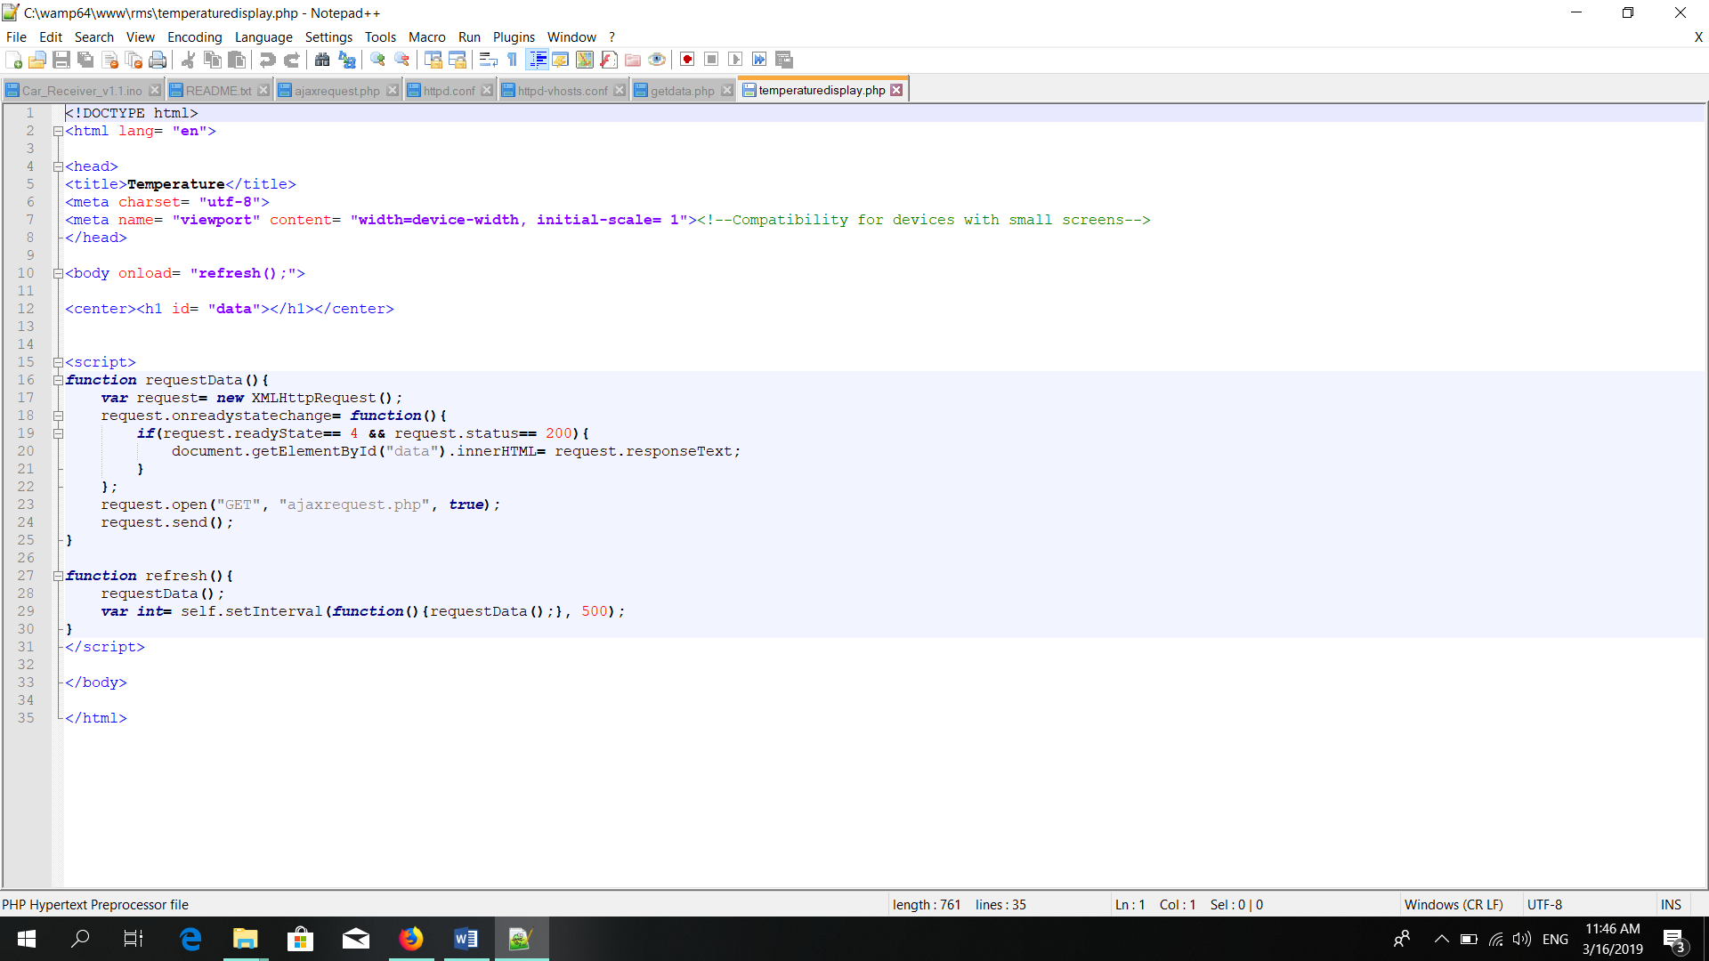Displaying Result

Result:

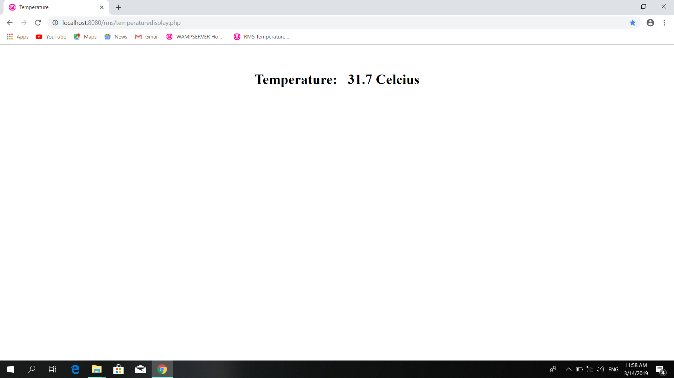

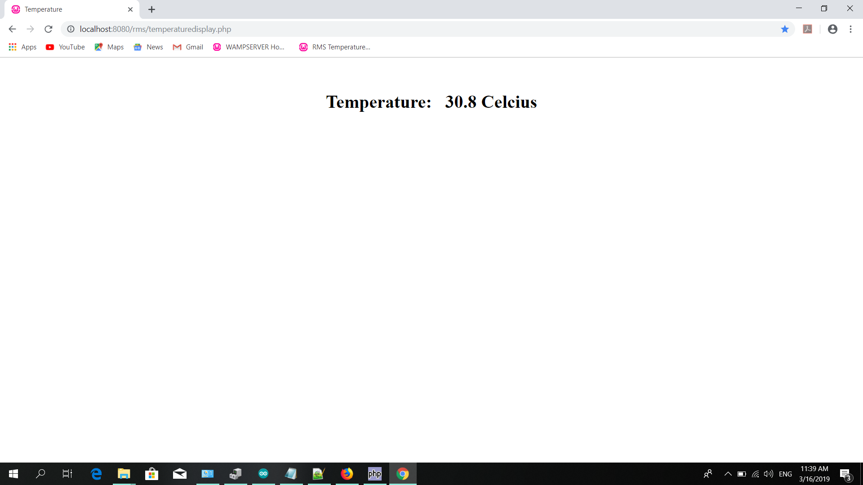

The temperature level auto update with the current temperature level.

~~This temperature method is very useful for the rescue teams to identify the temperature level of the current incident. Unlike other system by using this method we can also pre identify the temperature differences.~~

# 4.0 Network Communication

## 4.1 Network Components

The network components used in this project

* HC-12 module
* Wi-Fi adapter
* 433mHz Antenna
* Transmitter - Tx
* Receiver – Rx
* ESP 8266 module

**HC-12 module** –

This is a half-duplex wireless serial communication module. It can provide 100 channels in the range of 433.4-473.0 MHz that is capable of transmitting up to 1 km.

* Capture remote controlling signal
* Process the signal
* Send the processed signal to the motor drive

**Wi-Fi Adapter** –

There are two libraries in Wi-Fi adapter.

1. Wi-Fi
2. HTTP

If there is a loss of Wi-Fi connection, there is a reconnection option in this system. HTTP GET method used in this system. This will provide a LAN connectivity between the devices.

**433mHz Antenna** –

This will provide a range extension to the system. By using this we can control the robot up to 1.5km open field. This will connect to the joystick module and to the robot.

**Transmitter (Tx)** –

A transmitter is a device utilized in telecommunications to provide radio waves so as to transmit or send knowledge with the help of an antenna. The transmitter is in a position to come up with a frequency AC that's then applied to the antenna, which, in turn, radiates this as radio waves.

* The Tx pin is in the Uno board.

This will provide a signal according to the code in Arduino IDE.

**Receiver** **(Rx) –**

A receiver could be a hardware module or device accustomed receive signals of various sorts, counting on the context of the applying. it should receive analog magnetism signals or waves, or digital signals through wired media. The term receiver, however, is generally employed in communication, specifically wireless communication in terms of networking and cellular communication.

* Rx pin is in the UNO board

This will capture the signals according to the transmitter.

**ESP 8266 module –**

This module connects to the Wi-Fi. This will send data to the server. This will communicate via the serial protocol.

## 4.2 Network Monitoring Tools

We can use wireshark to identify the network communication.

Ex:

Wi-Fi connectivity in the Temperature sensor.

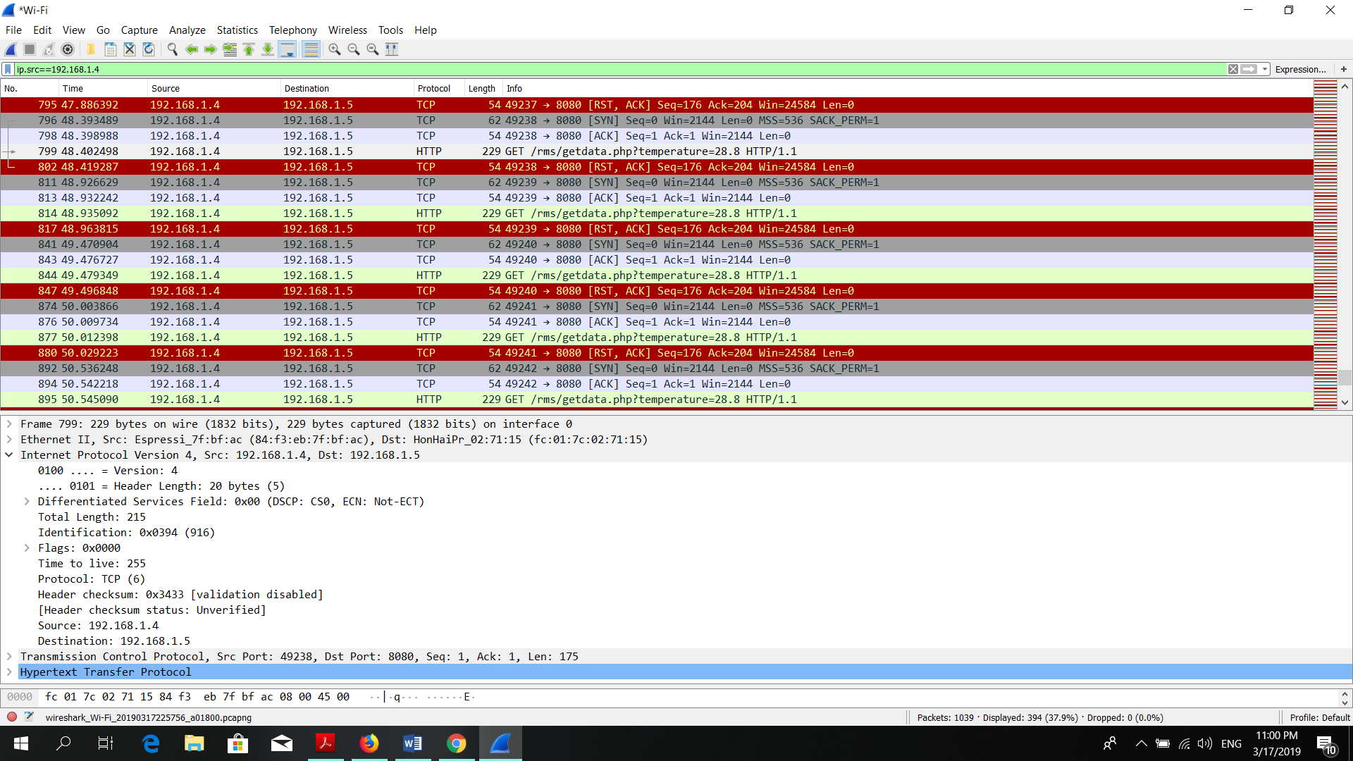

Filtering Command = (ip.src==192.168.1.4)

1. Configure the setting in Network Interface
   * Router name
   * Router password
   * IP address

#define WIFI_AP_NAME "SLT-ADSL-648B5" //Router Name

#define WIFI_AP_KEY "GayaNtha95#” //Router Password

HTTPClient http;

String server_ip_address= "192.168.1.4:8080"; //Destination server address.

String temperature= "35.7"; //Default for testing.

1. Upload code to the Robot
2. Run WAMP server
3. Run the particular link to identify the temperature level <http://localhost:8080/rms/temperaturedisplay.php>
4. Open Wireshark
5. Filter the IP (ip.src==192.168.1.4)

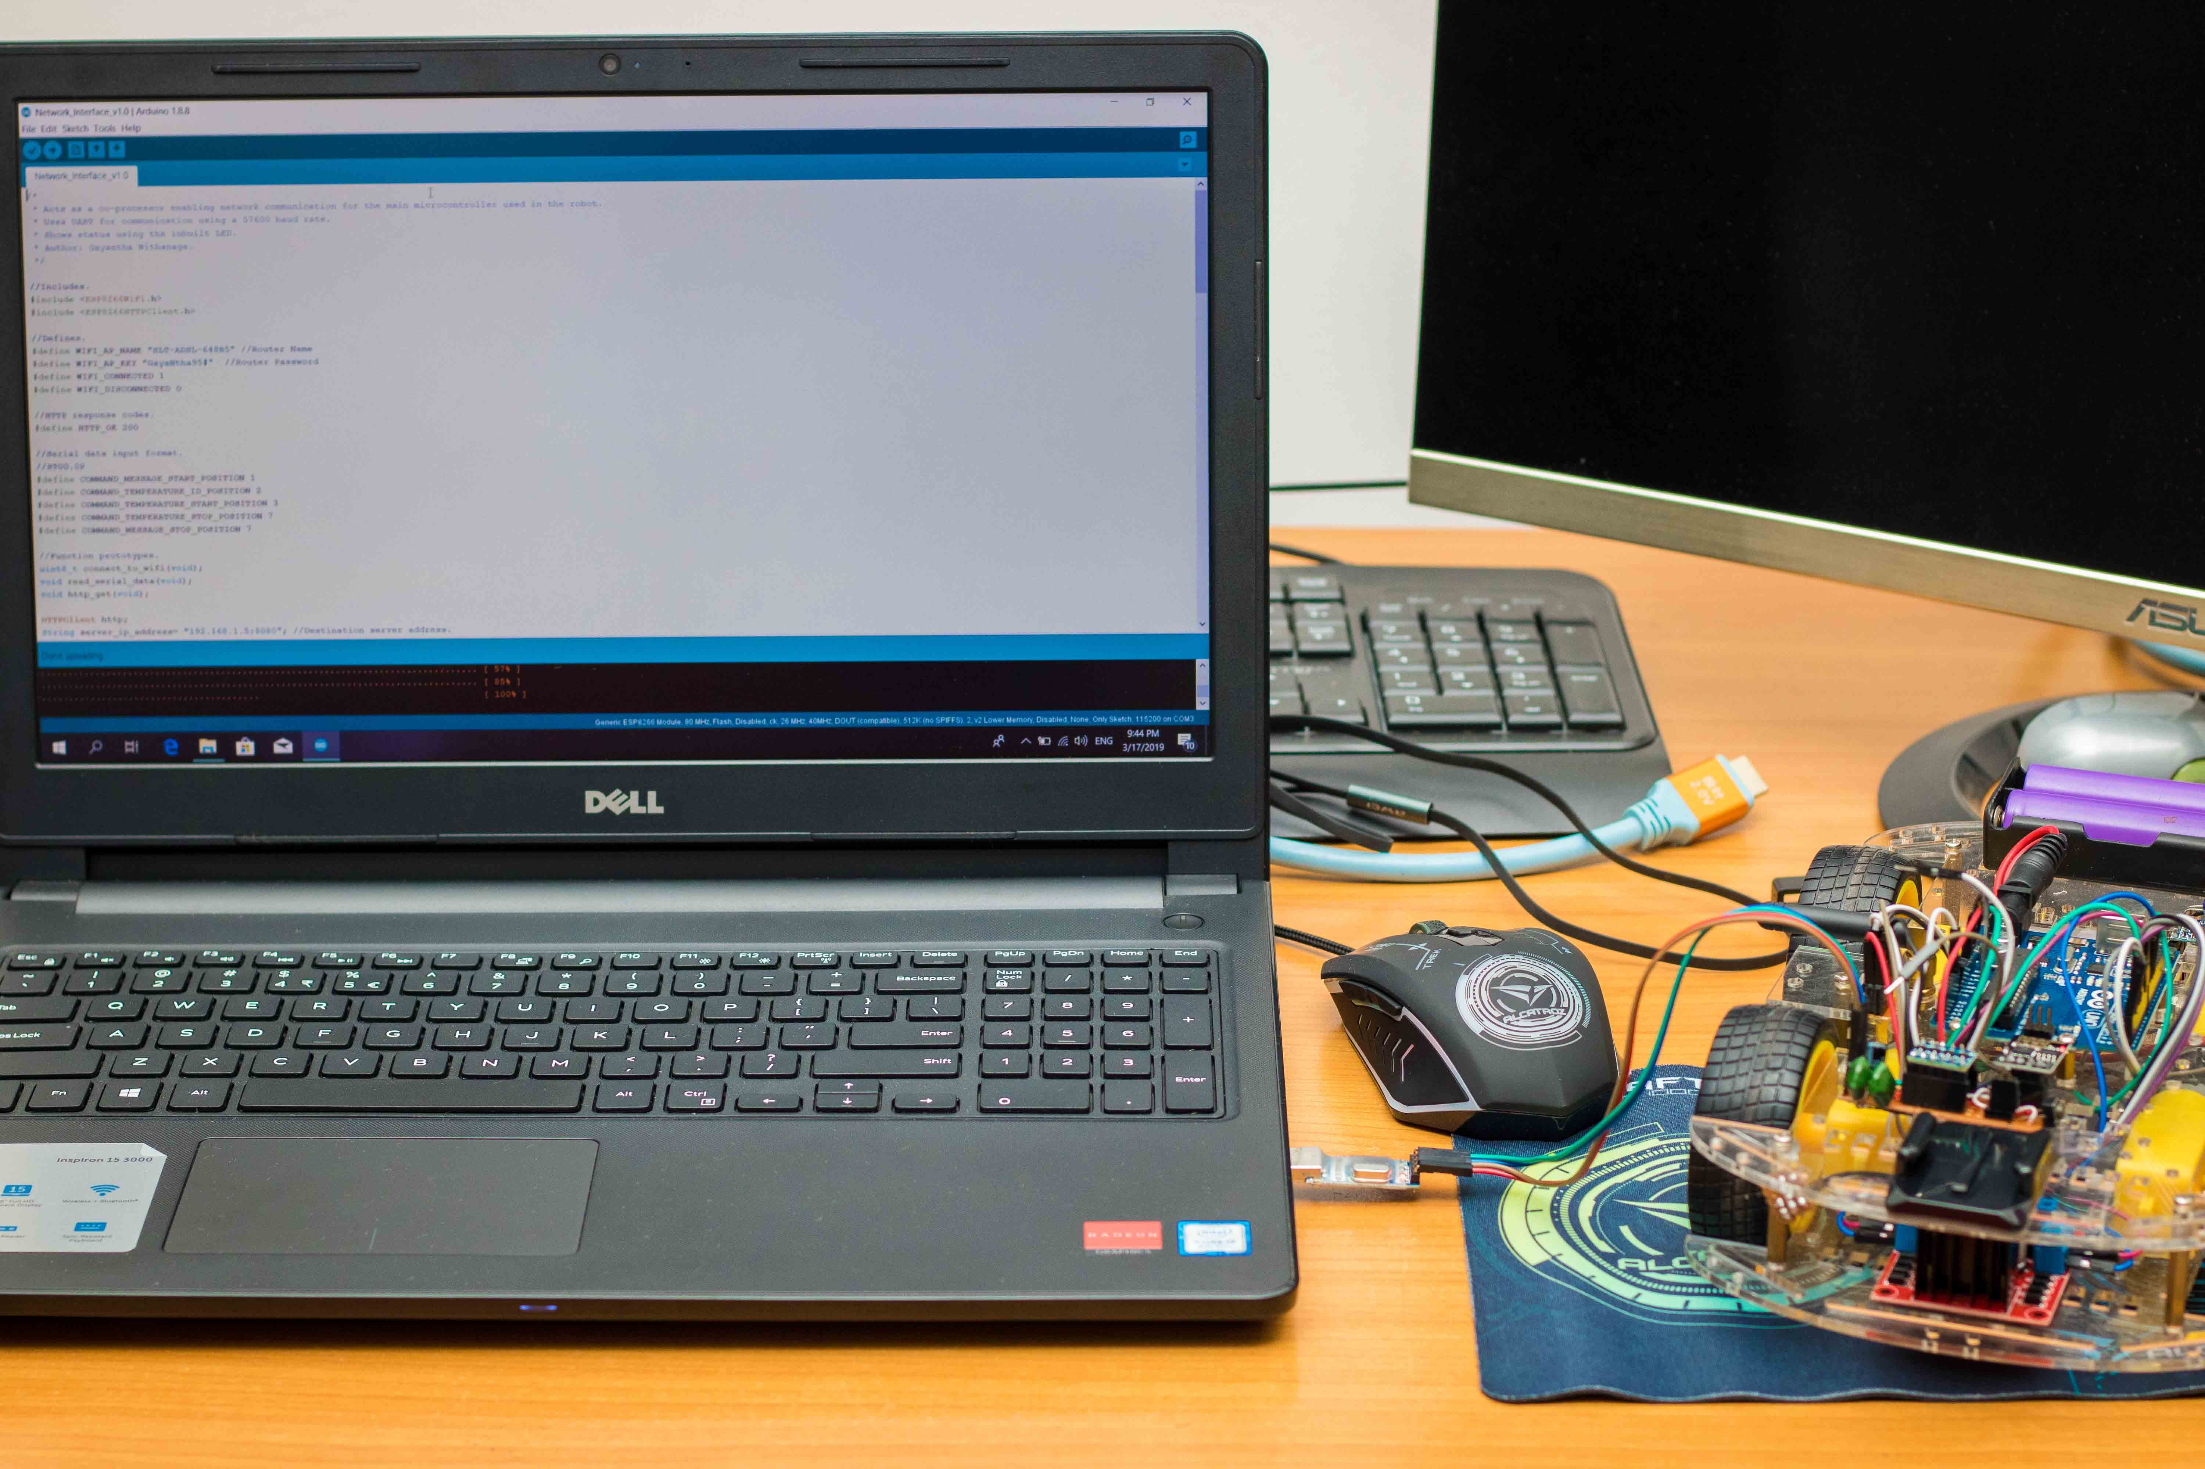

* Uploading the network interface IDE.

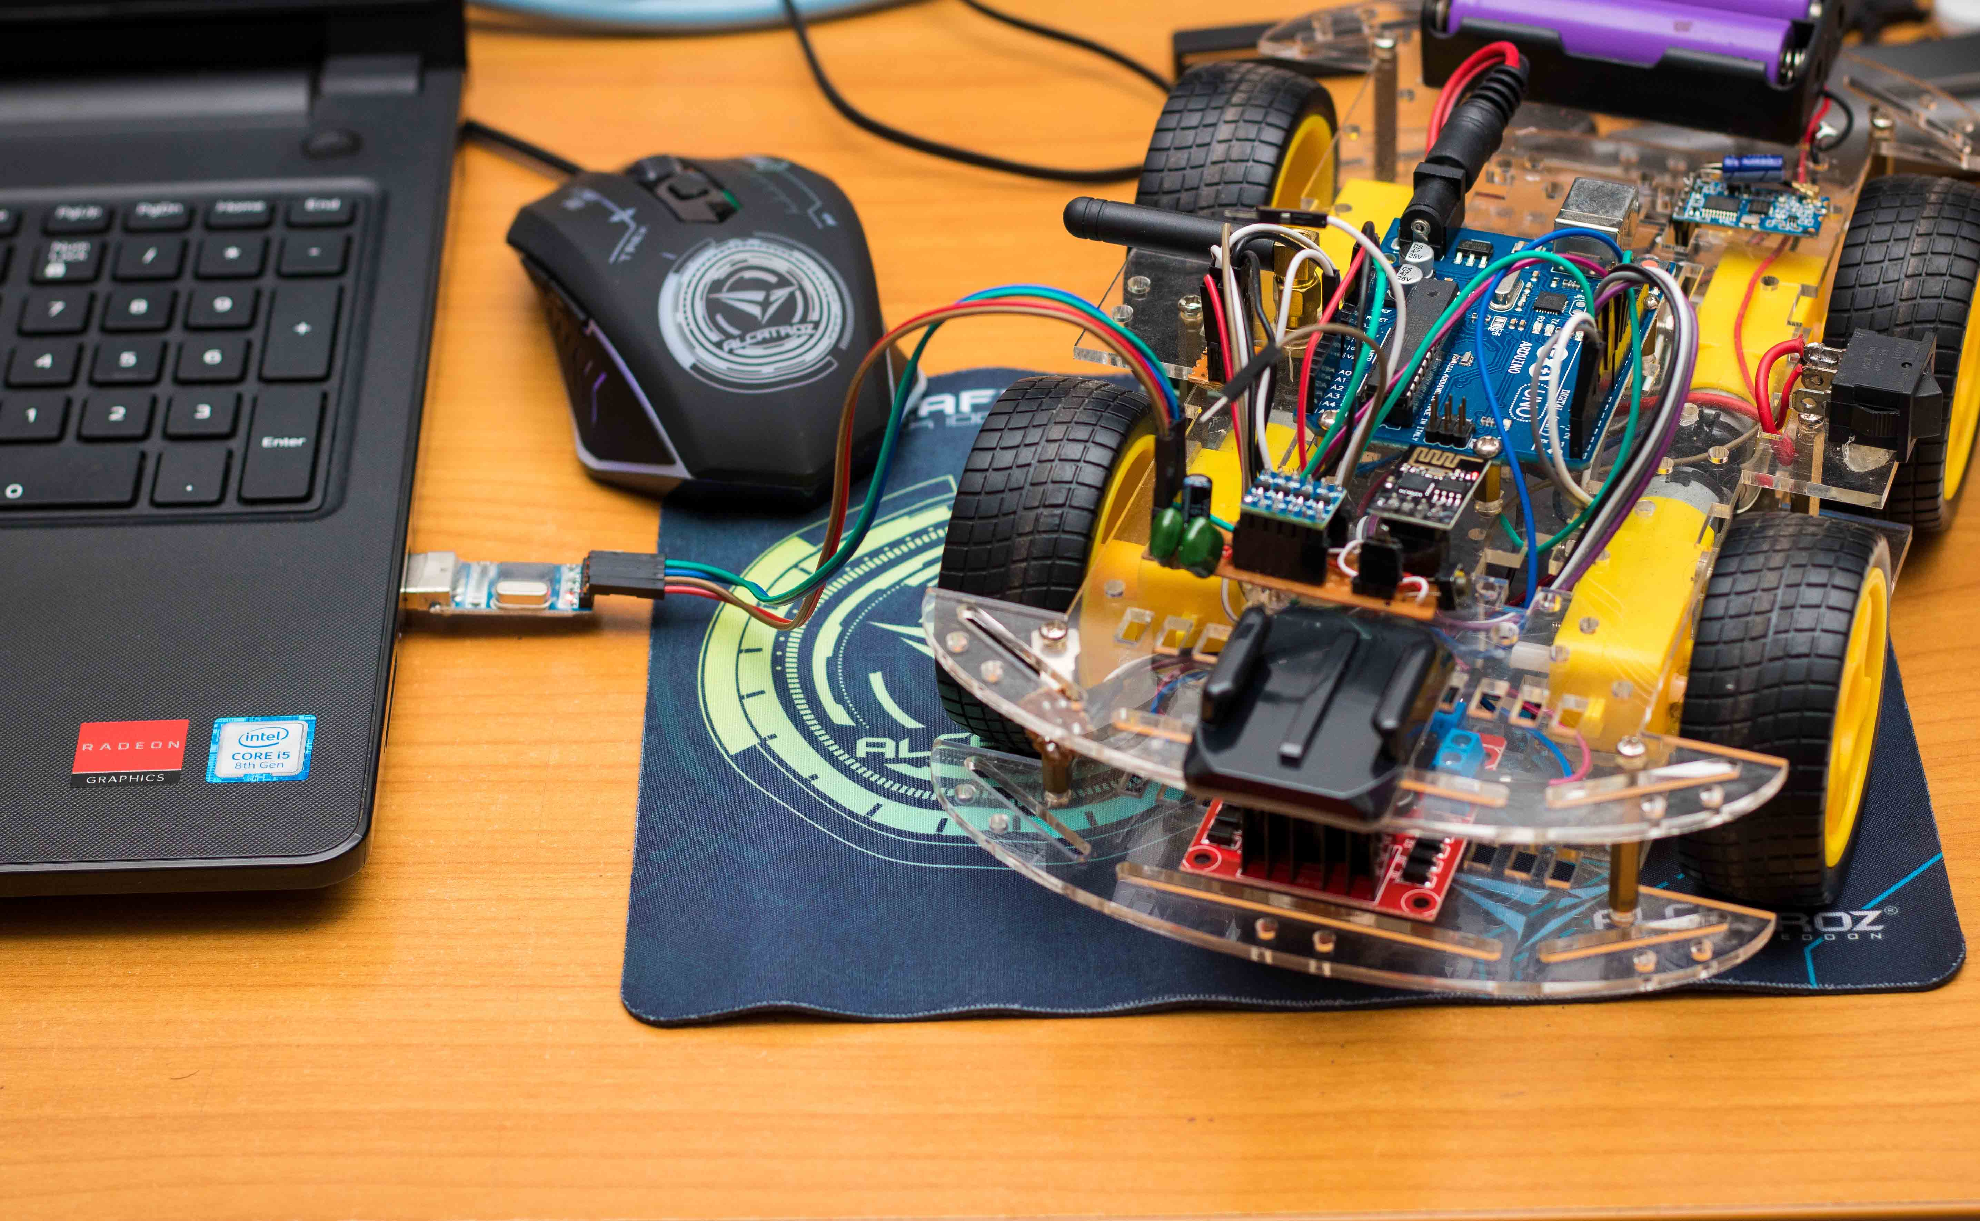

* Successful communication in Temperature Sensor

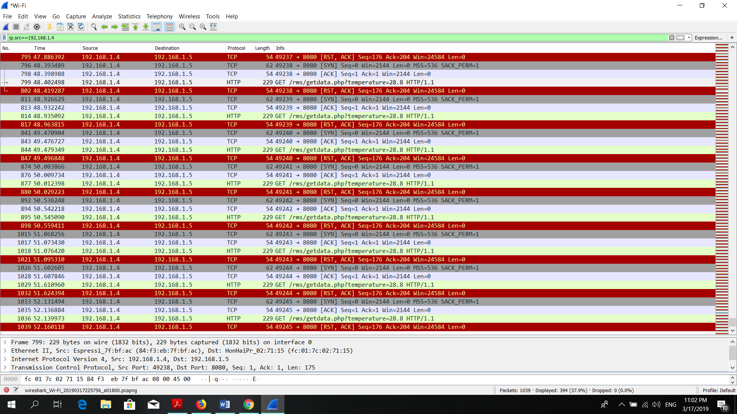

HTTP GET method

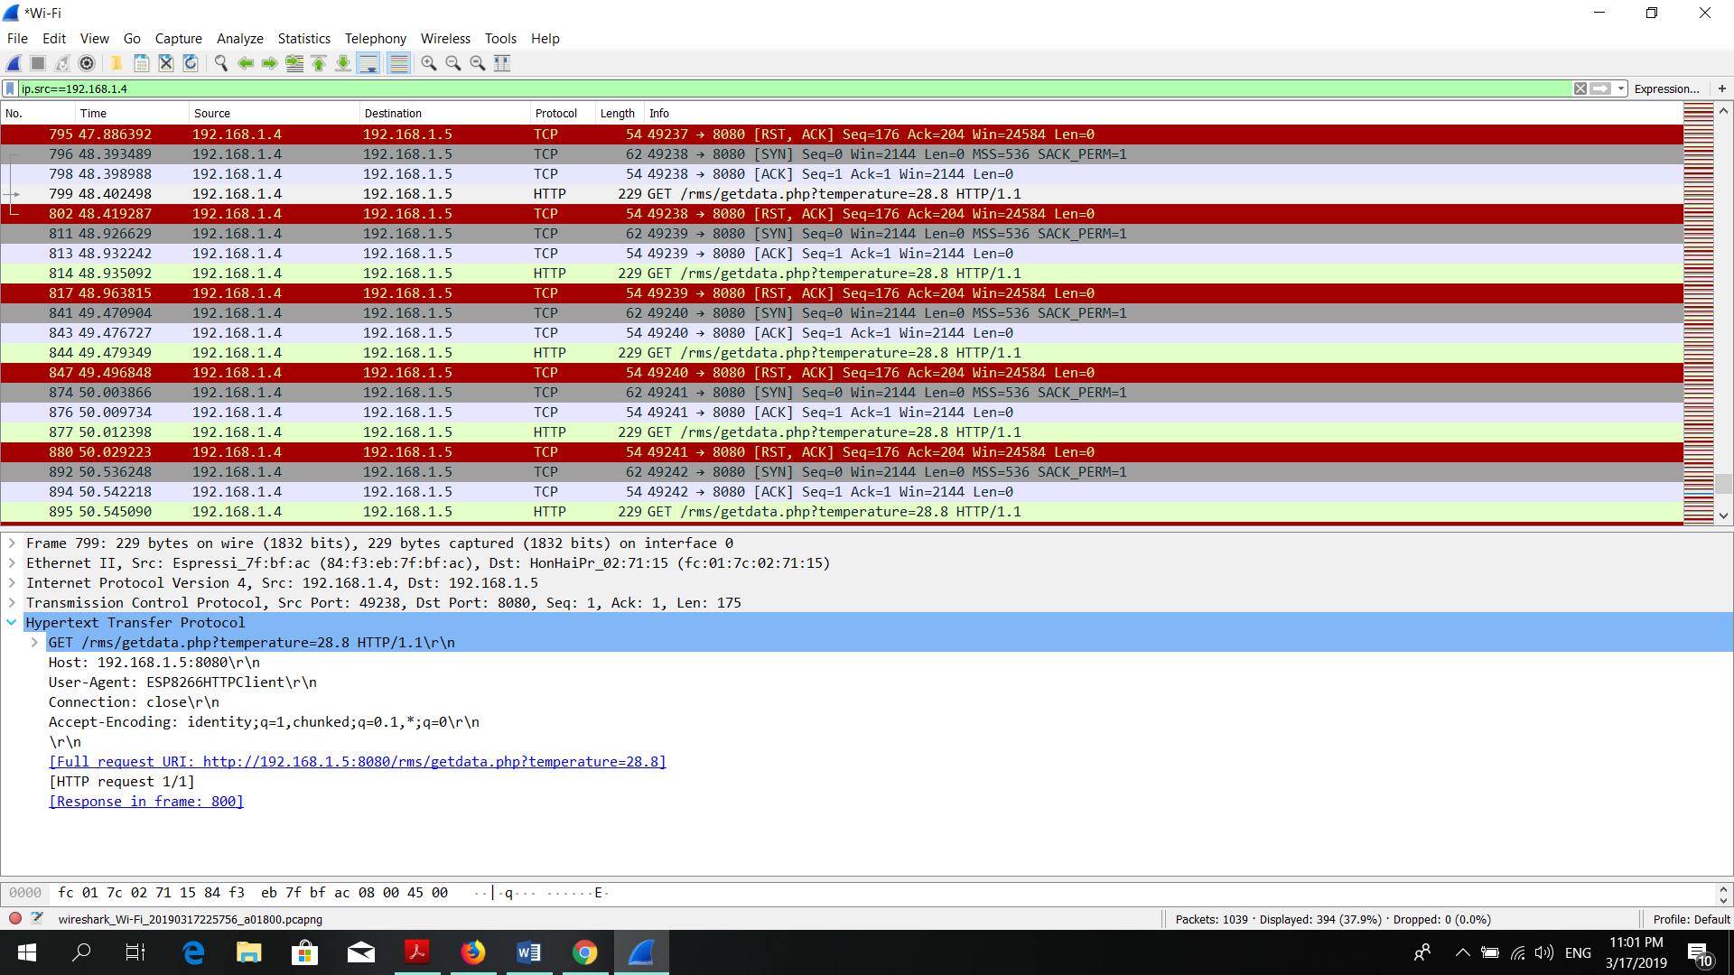

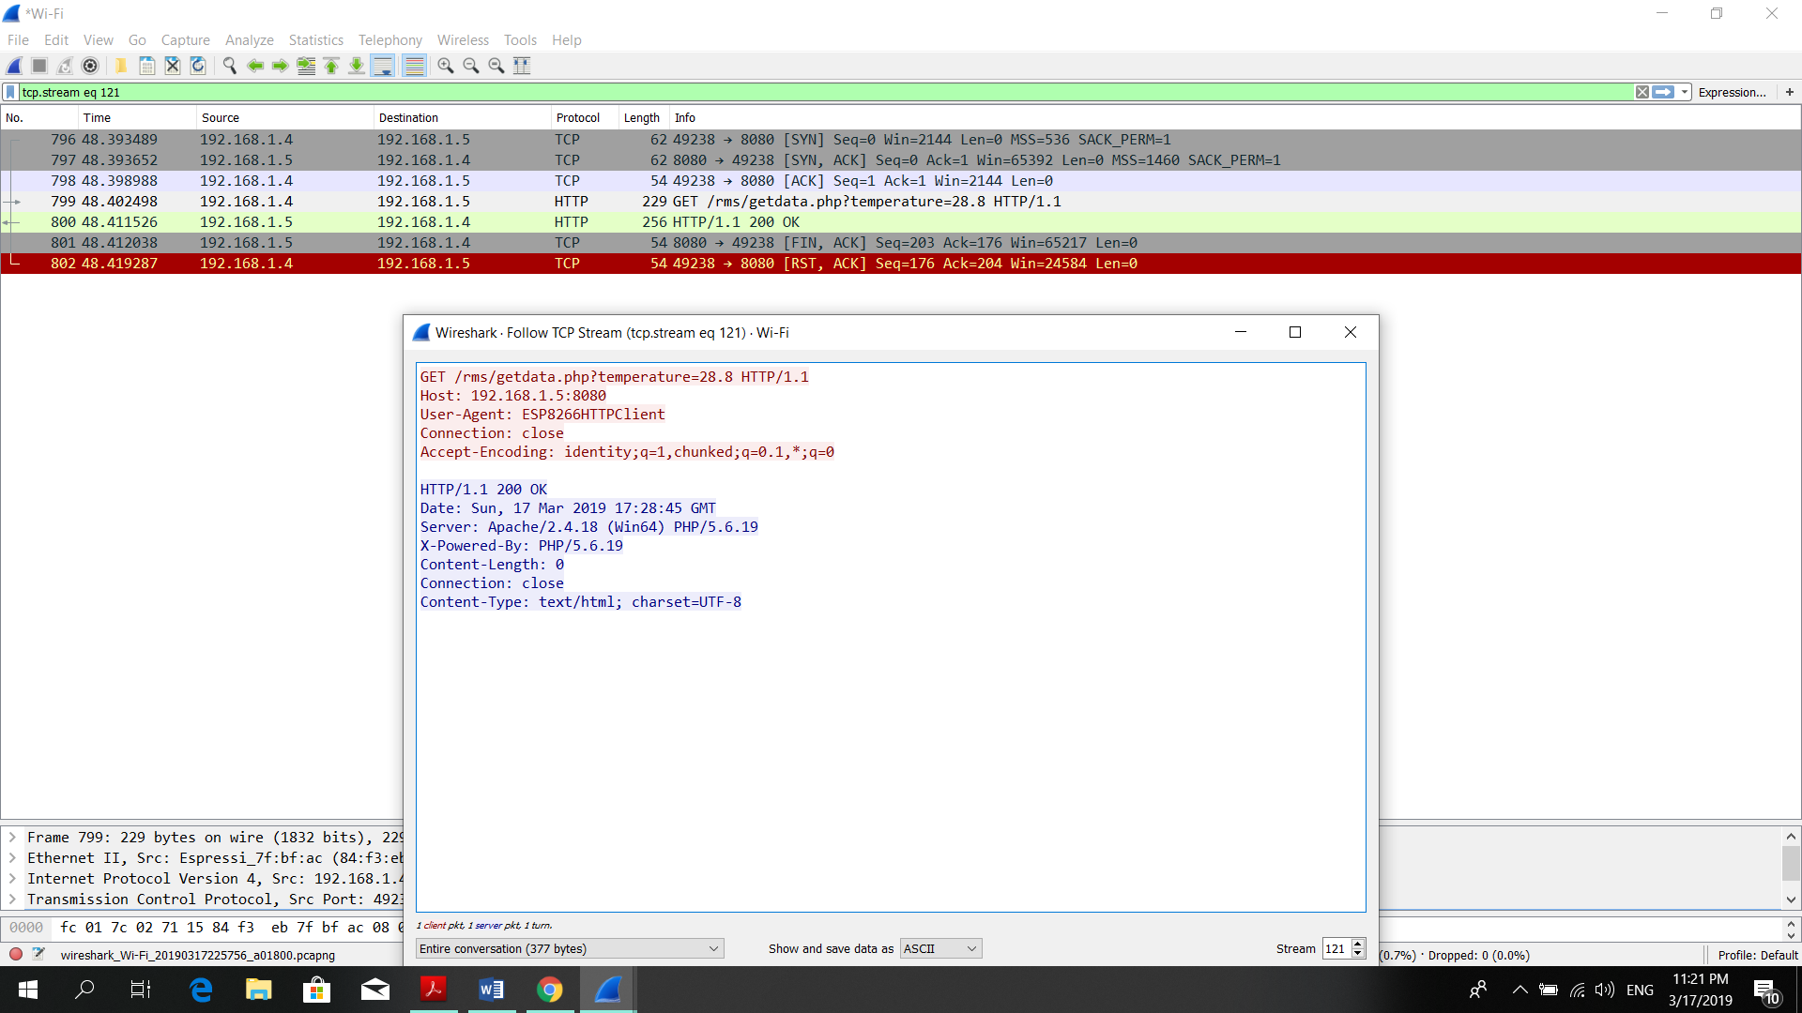TCP Stream:

# 5.0 Web

## 5.1 Designing the web

User designed principles are also used to design an effective interface for the web. Normally the web users are more likely to judge the system by its interface rather than its functionality. A system with high quality design interfaces will leads to grab users to the system and it create an interaction between the user and the system which will help the user to avoid the errors when he/she is performing a task.

* Visibility
* Feedback
* Affordance
* Self-explanatory
* Consistency

The website is designed using MVC architecture.

Send Request Display

Manipulate

Model –

This will represent the data and business logic. Marinating the data of the application.

View –

This is the user interface. This will display the data to the user.

Controller –

Controller is the request handler. That means the user can view, edit or delete the data.

The techniques that has been used to develop the website are:

* ASP.net
* MS SQL server
* Bootstrap 4

**Technical Specification:**

* The designed system is totally help for effectively apply for any urgency or emergency instances.
* The system interfaces are designed in order to communicate the system actions to the user.
* The system used a common user interface to facilitate a consistent between user and it helps the system to reduce training, increase productivity and performance. It makes the system more users friendly.
* The system provides edit, view and delete options to the user.
* To login to the system user must be a registered person
* User can log into the system using Facebook and Google+

When dealing with interface designing parallel design is an important technique to identify the best results by considering the requirements of the user.

## 5.2 User Control

## 5.3 Database

## 5.4 Validation

## 5.5 Response

# 6.0 Project Management

Project planning is the most important task in system development life cycle (SDLC). Project planning is task which is performed before the system actually begin. The first thing is select the software development methodology.

Commonly used methodology:

* Agile Development Methodology
* Waterfall Development Methodology
* Rapid Application Development Methodology
* DevOps Deployment Methodology

All methodologies have distinctive strengths and weaknesses. Agile Development Methodology is the best way to do this project.

## 6.1 Initial Project Plan

|  |  |  |
| --- | --- | --- |
| **6. Project Plan** | | |
| **Stage** | **Deadline** | **Products/Deliverables/Outcome** |
| 1. Initiation | 28/11/2018 | PID |
| 2. Investigation and requirements | 10/12/2018 | Analysis of existing business processes  Requirements document  Evaluation of possible development technologies |
| 3. High level design | 15/12/2018 | Design documents |
| 4. Increment1 | 25/12/2018 | Designing Arduino Robot |
| 5. Increment2 | 10/01/2019 | Designing and complete the web site |
| 6. Increment3 | 25/01/2019 | Testing the Robot and web site |
| 7. System and user acceptance testing | 30/01/2019 | Final system; user training |
| 8. Assemble and complete final report | 10/02/2019 | PRCO303 Report |

The above table contains the 1st project plan of my system. This table also included to the PID report.

The initiation stage marked the beginning of the project. The main objectives for this stage were to gain approval for the project and to complete the Project Initiation Document (PID). Firstly, to gain approval for the project, a decision had to be made on what functionality the system would provide and the objectives for the project. Achieving this would include research into finding feasible technologies and tools to use. After this initial investigation, it was decided that the project would be the management of wireless access points. Once the project had been approved, the first draft of the PID document was written.

## 6.2 Investigation Stage

This stage involved a much deeper analysis of the technologies chosen from the initiation stage.

* Analysis of existing business processes
* Requirements document
* Evaluation of possible development technologies

## 6.3 Design Stage

Towards the end of the investigation stage, the initial design phase began. This stage involved the creation of design documents such as the Arduino IDE, Database and Wireless communication and diagrams.

Technologies - WAMP Server 64

Visual Studio 2017

Microsoft SQL Server 17

Arduino 1.8.8

Notepad ++

Wireshark 3.0

## 6.4 Communication Plan

Target User Groups –

* Rescue team (Fire team)
* Police department
* Army
* Head of the IT in any firm
* Laboratories
* Director Board - IT

## 6.5 Risk Management

* Connection between the Arduino tool kits.
* Controlling errors – Remote controlling difficulties
* Network connectivity Issues
* FB and Google access to the Web
* Temperature measurement
* ASP.net features

Risk Management is a formal process which is used to explore, examine, analyze and manage risks. In order to gain optimal steps for reducing the risk by avoiding it or mitigating it, there are steps that need to be taken to ensure effective risk management. When creating projects, natural disaster can happen but consider about manageable risk. Which are deadline overrun, project failures, worker’s problems, budget overrun, network failures etc.

|  |  |
| --- | --- |
| **Initial risk list** | |
| **Risk** | **Management strategy** |
| Schedule overrun | Contingency has been introduced into the project plan. Highlight reports will provide a regular monitoring of schedule. An exception plan will be developed, and approved by the project supervisor, in the event of more than 1 week’s slippage |
| Difficulty learning/using the development technologies | Latest Arduino Version | ASP.net 2017 | Bootstrap 4 |
| Requirements breakdown | Rescue team can modify the web site details as they want.  View | Update | Delete |
| Technology failure | The system will be deployed using standard technologies, and system backups will be taken daily |

## 6.6 Cost Estimation

This constraint has the ability to change the whole project. Cost estimation is one of the main objective in this project. In "Agile Methodology" there are more testing occurring during the development. So I need to more finance to the testing. In “Agile”, cost estimation is important through the project. If I fail to plan cost estimation, project is failed toward at the end. The cost estimation mainly used for the Arduino equipment in this project.

# 7.0 Requirements

## 7.1 Functional Requirements

* The system shall allow the user to log, view, modify and delete related information
* Provide previous incident photos and videos
* Allow the registration to the new users
* Can login using Facebook and Google accounts
* Provide login and logout
* Can identify the temperature level using the robot
* Can stored the captured data from the robot
* Easy to control the robot

## 7.2 Non Functional Requirements

Non-functional requirements were used to describe how the system should work, aiming to cover areas like performance and maintainability of a system that are not mentioned in functional requirements. They are important to ensure that the system has quality and that the system is usable as well as effective

* System has a user friendly interface
* Run effectively and provide high performance to the user

# 8.0 Testing

## 8.1 Functional Testing

Testing has been carried out in order to verify the performance of the application. At the initial stage of the project, the core component was divided into main sub components. After these intermediate deliveries, system has been tested appropriately. Functional Testing is a technique that ensures that the software is quality assured. The technique is used to test all of the features and functionality of the system. These tests should include failure paths and boundary cases.

The development technologies that have been used for this project were the right choice, no significant issues were posed during the development process.

* WAMP Server 64
* Visual Studio 2017
* Microsoft SQL Server 17
* Arduino 1.8.8
* Notepad ++
* Wireshark 3

All technologies that have been used to develop this system work properly. Robot working properly.



Successfully uploaded Temperature Code

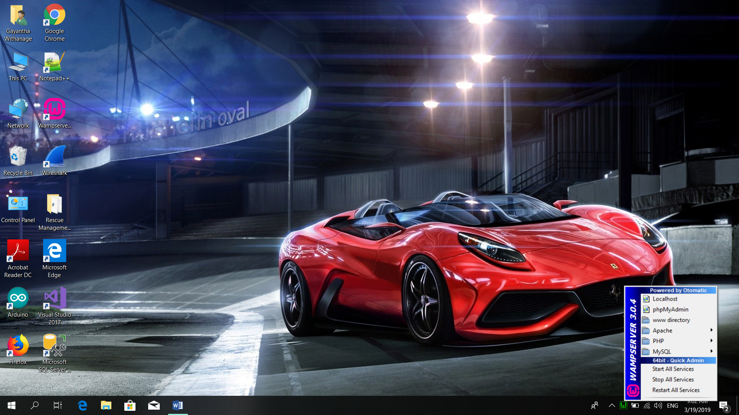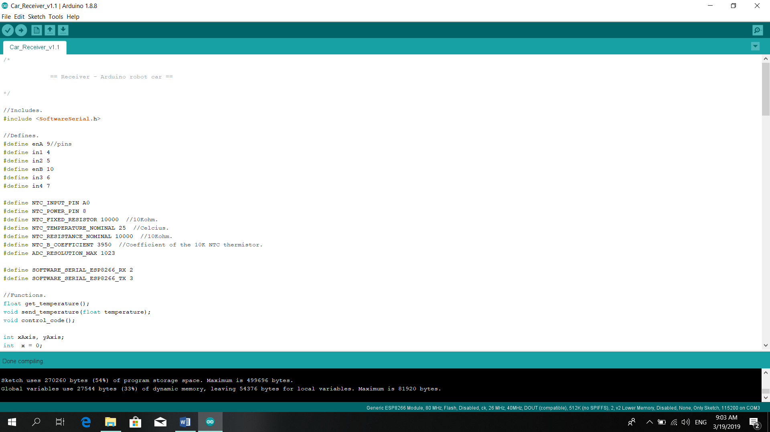 Arduino IDE Compiling without errors – Safe Robot

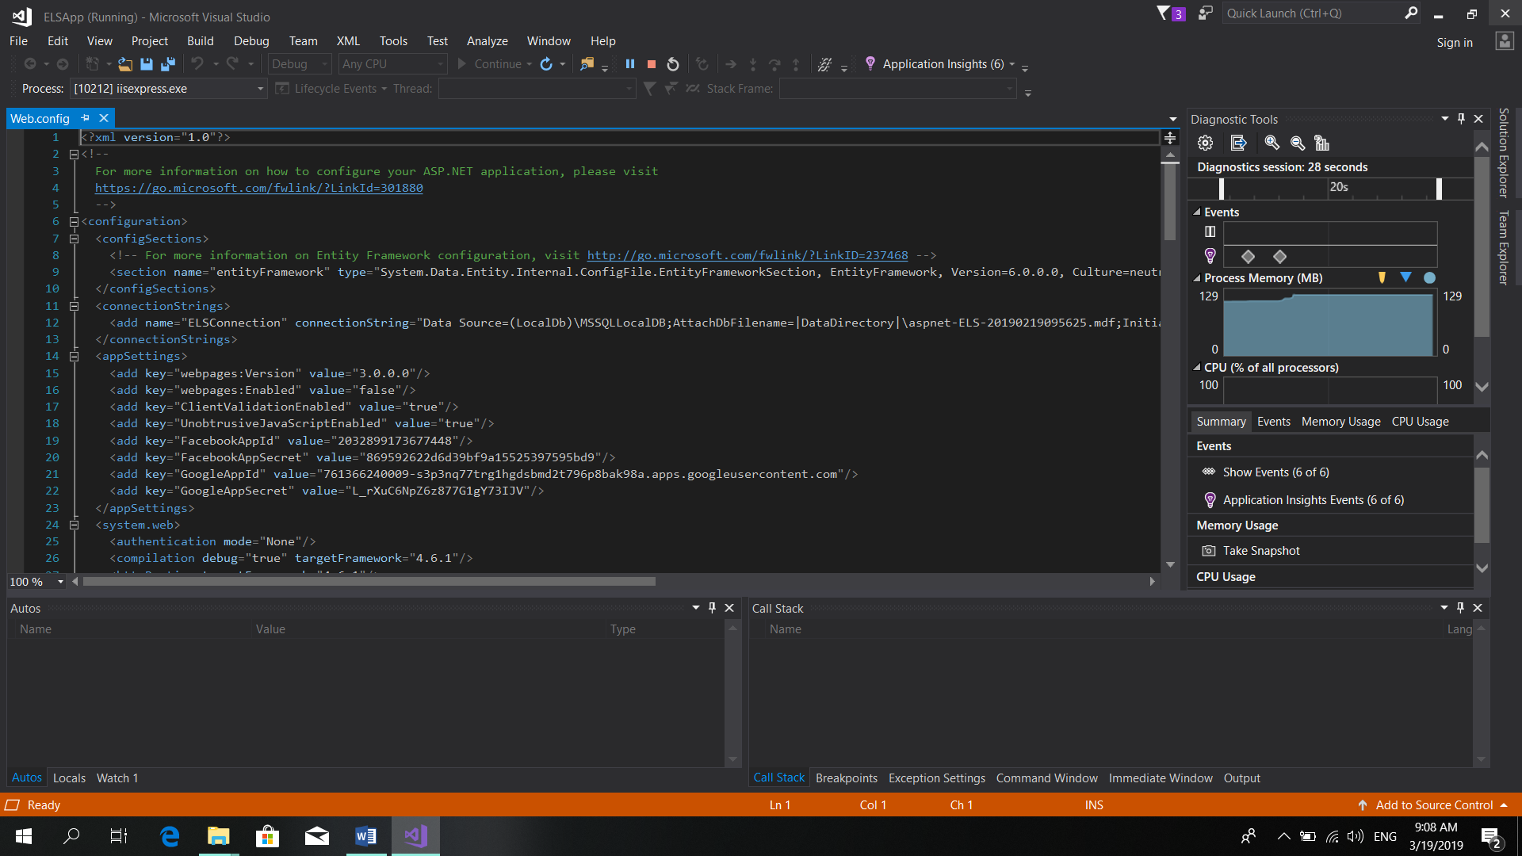

WAMP working

Properly

Web Page loading without getting

Errors.

## 8.2 User Testing

User testing was also carried out to evaluate user-friendliness of the application. Application is developed in a way that any new user can understand the entire application without any complication. Furthermore, codes snippets are commented accordingly.

In a nutshell, some important factors which were testing for the entire application are as follows.

* Verification of application requirements with the final features available in the system
* Reliability of generated results/predictions
* Verify the user-friendliness of the final output
* Controlling the Robot
* Identify the Temperature level

Usability testing is a standard tool used to evaluate the usability of the system. The users are encouraged to think out loud while testing the Robot and web. Once they have completed the tasks, they are asked to complete a feedback about their experience of using the software

### 8.2.1 User 1



Shanika Dilrukshi working as a Guest Relations Officer at Amari Galle Sri Lanka. Former Student of NSBM graduated with BSc (Hons) Events, Tourism and Hospitality Management at Plymouth University UK.

I personally tried this Rescue Monitory System. In case of any emergency situation for instance at a Fire we can send this robot to estimate the amount of damage that it can cause by taking photos and Videos through the connected Action Camera. And the best thing is those data is being uploaded and saved at that same instance through the Web to be kept as a Store. This device is very User friendly and very convenient. Moreover, it can only be accessed or logged in by an authorized person. If we do not have any account, we can sign up or even sign in through Facebook or Google+. So this project will help the community. Thank you.

### 8.2.2 User 2



Ashen Kalhara working as a junior tour executive at Destination Management Company.

What I personally believe about this rescue monitory is it is a great invention with user friendly mechanism and moreover this device is accessible only for the authorize people who have the accounts under this device. We can effectively apply this theory for any urgency or emergency instances like fire, earthquakes and so on. This feature has the ability to estimate the amount that the destruction cause as it records the footages of each situation and it enables to store it in a separate memory.

# 9.0 End Project Report

## 9.1 End Project Summary

Overall the project was successful. The major goal of this project was to make a safe robot and develop a web application that would allow target users to spend their time and track their progress. The application produced included all of the core functionality and most of the desired functionality. I believe all of the technologies used to produce the system were perfect for my needs.

## 9.2 Project Objective Review

After the project had reached its conclusion, a working system has been developed which satisfies most of the project objectives laid out in the original Project Initiation Document (PID). Arduino robot and web page have been created and configured securely. The performance and speed of the robot is in high level. The user requirements objective was completed by analysing functionality offered by the web that had been researched. The system allows for users to remotely control the robot. This objective had been met by conducting extensive research in the initial stages of the project. Many factors were considered when researching what technologies could be used to develop the solution. All of the technologies chosen were best suited to the project. A class diagram was produced to design the structure of the database and how the objects in the database would relate to one another. Technologies were judged during the development stage to ensure the objective was continually met throughout the project to ensure any choices were informed and would provide the benefits required. Finally, the primary purpose of this report was to discuss the project and the work that it entailed, including the evaluations within this and the following sections. These have been used to appraise the success of the project, completing the remaining objective of the project.

|  |  |  |
| --- | --- | --- |
| **6. End Project** | | |
| **Stage** | **Deadline** | **Products/Deliverables/Outcome** |
| 1. Initiation | 28/11/2018 | PID |
| 2. Investigation and requirements | 10/01/2019 | Analysis of existing business processes  Requirements document  Evaluation of possible development technologies |
| 3. High level design | 05/02/2019 | Design Class Diagram | Use Case |
| 4. Increment 1 | 12/02/2019 | Designing Arduino Robot |
| 5. Increment 2 | 08/02/2019 | Designing and complete the web site |
| 6. Increment 3 | 10/02/2019 | Testing the Robot and web site |
| 7. Initiation:2 | 15/02/2019 | Interim Report 1 and 2 |
| 8. Add Thermistor | 10/03/2019 | Finalizing the Arduino robot.  Troubleshooting |
| 9.Displaying Temperature | 12/03/2019 | Temperature measurement display |
| 10.Increment 4 | 14/03/2019 | Testing the Robot and web site and Temperature Identifier |
| 10. System and user acceptance testing | 16/03/2019 | Final system; User training |
| 11. Assemble and complete final report | 25/03/2019 | PRCO303 Report |

# 10.0 Post Mortem

## 10.1 Development process and Technologies

For most of the project, the development of the system has mostly met the deadlines laid out from the PID. However, I dedicated more time to the development of the interface and the writing of the final report. The project idea itself was defiantly an excellent choice of mine. Reasons for this includes own personal interest in the subject matter, but also managed to find sufficient support from documentation to help improve personal understanding of some of the technologies used. Given better resources and more time, the system would have been designed to record the values of all second. In this way, the average over the hour would have been a lot more accurate. The project objectives were right for the project as they helped guide the project to ultimately create the desired system successfully. As each objective covered a specific area that was worked towards it ensured that the project was carefully planned out, so the project was split into stages to meet each objective; improving and understanding to better meet the deadline. An objective that should have been included was to consider the system architecture, as although this was done, it was not considered as a priority so less time was dedicated to it.

## 10.2 Personal Performance and Lessons Learnt

Choosing Agile over Waterfall to use in development was the best choice for the project as there was little time for full planning and design, and phases like testing were often revisited within sprints for changes. This would not have worked with Waterfall due to its sequential nature and would have led to the development phase being shortened from extensive planning phases. The development technologies used during the project were the correct choice as no significant defects were encountered during development or testing. MSSQL server was the best choice for database as the amount of data potentially stored by users could not have been stored locally. C# was a useful language for Web development. It also offered many libraries and MVC were critical to the project success. To build the Robot mainly in Arduino IDE, C language was used.

Overall I enjoyed the project as I was able to use knowledge I had accumulated during my time at university and apply it to a project, which if further developed, could provide real use to many people. An area the project has shown needs improvement is time management and task estimation as often tasks took longer than expected. Mainly with the troubleshooting. I believe my performance during this time was good as the project was delivered on time and tested to have quality, with all core deliverables that covered priority requirements implemented. My performance could have been improved by doing more tutorials before starting the project to lessen the delay during development, which would have likely allowed time to implement lower priority requirements and finish the prediction aspect in a way that is more tailored to the user. A particular area of the project I enjoyed were learning how to code in Visual Studio using C# and Arduino IDE using C language. In future I wish to apply more advanced C# codes to the web.

Some areas that I have covered from this project –

* Stored Procedure
* Data Retrieve method
* SQL connection
* SQL Data Reader
* SQL Data Adapter
* Coding in Arduino IDE
* Wireless communication
* Coding in Arduino IDE
* Coding in Visual Studio 2017
* Server Connection
* Packet Capturing and analyzing using Wireshark
* Connectivity between the Arduino Equipment
* Advanced coding in C language

The requirements and determining whether the project was a success would have been easier if a customer had been involved, as the Rescue Management benefits and requirements could have been extracted directly rather than using background research; meaning they would be clearer and more accurate. The web application has a real potential to help in any emergency need. Also I improved my skills in C# and C language as well.

# 11.0 Backup Plan

# 12.0 Conclusion

# 13.0 Bibliography

(n.d.). Retrieved from https://components101.com/ntc-thermistor-10k

D Ruwandi, D. ( 2018, October 11). Retrieved from http://www.dailymirror.lk/article/Fire-at-Cool-Planet-156734.html

Dejan. (n.d.). *Arduino and HC-12 Long Range Wireless Communication Module*. Retrieved from https://howtomechatronics.com/tutorials/arduino/arduino-and-hc-12-long-range-wireless-communication-module/

Hughes, M. ( 2016, November 02). Retrieved from Understanding and Implementing the HC-12 Wireless Transceiver Module: https://www.allaboutcircuits.com/projects/understanding-and-implementing-the-hc-12-wireless-transceiver-module/

*pcmag.com*. (n.d.). Retrieved from https://www.pcmag.com/encyclopedia/term/56199/wireless-adapter

Pelayo, R. ( 2018, March 14). *Arduino Tutorial*. Retrieved from https://www.teachmemicro.com/use-l298n-motor-driver/

# 14.0 Appendix

## 14.1 Appendix 1 – PID

**Introduction**

This is an Arduino and web based project which the user can remotely control in an emergency need. If there is any disaster, before the people involve, this robotic component can take the photos and video about the current situation. And the system handler can estimate the necessary actions to solve that disaster or incident. To store the incidents that has happened we use a desktop application.

Business case

**Business need**

In our country there is no any rescue monitoring system in current. If there is any emergency work people will involve for that. In many cases people face for accidents in that situation. To avoid that I introduce this system to the clients.

**Business objectives**

* It can be entered in a small space
* Measuring the incident type
* Device handle by the main user
* Can get photos and videos of the system
* Incident update to the database manually
* Unlike other remote devices the connection won’t be lose.

**Project objectives**

* Provide a real time service to the customer
* Maintaining a full detailed database about incidents
* To analyse potential development technologies and deployment solutions
* To implement the new Arduino system in line with new processes and procedures
* Remote Controlling facility

**Initial scope**

* Rescue team can remotely control the device
* Rescue team can monitor the incident and take photos and videos in that time.
* All incidents are recorded in the web
* The web site can generate an emergency mail to the necessary parties
* Arduino robot can control within 1.8km
* People can estimate the rescue teams easily

**Method of approach**

Possible technologies are ASP.Net/SQLServer, JS, CSS and Arduino IDE although a full evaluation will take place during the project.

* Arduino IDE / Arduino materials
* Wireless Camera
* 433 MHz Antenna
* XY joystick module
* 18650 Battery

**Initial project plan**

|  |  |  |
| --- | --- | --- |
| **6. Project Plan** | | |
| **Stage** | **Deadline** | **Products/Deliverables/Outcome** |
| 1. Initiation | 28/11/2018 | PID |
| 2. Investigation and requirements | 10/12/2018 | Analysis of existing business processes  Requirements document  Evaluation of possible development technologies |
| 3. High level design | 15/12/2018 | Design documents |
| 4. Increment1 | 25/12/2018 | Designing Arduino Robot |
| 5. Increment2 | 10/01/2019 | Designing and complete the web site |
| 6. Increment3 | 25/01/2019 | Testing the Robot and web site |
| 7. System and user acceptance testing | 30/01/2019 | Final system; user training |
| 8. Assemble and complete final report | 10/02/2019 | PRCO303 Report |

**Control plan**

* Full controlling statement about the Robot.

**Communication plan**

**Target User Groups –**

* Rescue team (Fire team)
* Police department
* Army
* Head of the IT in any firm

By using this system, we can save the people life and get the quick reactions in any incident**.**

**Initial risk list**

|  |  |
| --- | --- |
| **7. Initial risk list** | |
| **Risk** | **Management strategy** |
| Schedule overrun | Contingency has been introduced into the project plan. Highlight reports will provide a regular monitoring of schedule. An exception plan will be developed, and approved by the project supervisor, in the event of more than 1 week’s slippage |
| Difficulty learning/using the development technologies | Latest Arduino Version |
| Requirements breakdown | Rescue team can modify the web site details as they want. |
| Technology failure | The system will be deployed using standard technologies, and system backups will be taken daily |

**Initial quality plan**

* By using this system, we can save the people life and get the quick reactions in any incident.
* All requirements and design principles will be checked.

## 14.2 Appendix 2 – Interim Report 1

1. Introduction

This is an Arduino and web based project which the user can remotely control in an emergency need. If there is any disaster, before the people involve, this robotic component can take the photos and video about the current situation. And the system handler can estimate the necessary actions to solve that disaster or incident. To store the incidents that has happened we use a desktop application.

2. Tasks undertaken and outcomes

* In this project I have to create a robot with a remote controlling system
* So if any disaster or any emergency we can active this robot and remotely directed to that particular place to measure the damage estimate. After that we can suggest how many rescue teams should want to that incident.
* Well maintaining and updated web site is another outcome of this project. That will contain the all disaster details in an order.

3. Products produced and product quality

* In this project the main task is to build a full remote controlled Arduino 4-wheel robot that can controlled within 1.5km
* Safe Robot
* Arduino robot will build using the high quality network components and other Arduino equipment.

4. Risks that have materialised

* Connection between the Arduino tool kit.
* Controlling errors – Remote controlling difficulties
* Network connectivity Issues

5. Schedule

|  |  |  |
| --- | --- | --- |
| Component | Deadline | Description |
| * Build up the Arduino robot | 10/02 | Finalizing the Arduino robot.  Troubleshooting |
| * Creating the Web and Testing | 20/03 | Finalizing the web site and test it. |

6. Resources

* + Arduino IDE / Arduino materials
  + Wireless Camera
  + 433 MHz Antenna
  + XY joystick module
  + 18650 Battery
  + Transistors and Receivers

Resources should be available and safety. That means if any harm we can easily fix the components and the robot without any delay.

7. Student learning undertaken & required

* Trouble shooting with the errors that will occur in Arduino tools.
* Fixing the Arduino robot without any mistakes
* Knowledge about ASP.net
* Coding in Arduino IDE
* Knowledge in new software components and applications.
* Handling new Arduino components
* By using this system, we can save the people life and get the quick reactions in any incident.
* All requirements and design principles will be checked.

## 14.3 Appendix 3 – Interim Report 2

1. Introduction

This is an Arduino and web based project which the user can remotely control in an emergency need. If there is any disaster, before the people involve, this robotic component can take the photos and video about the current situation. And the system handler can estimate the necessary actions to solve that disaster or incident. To store the incidents that has happened we use a Web application.

1. 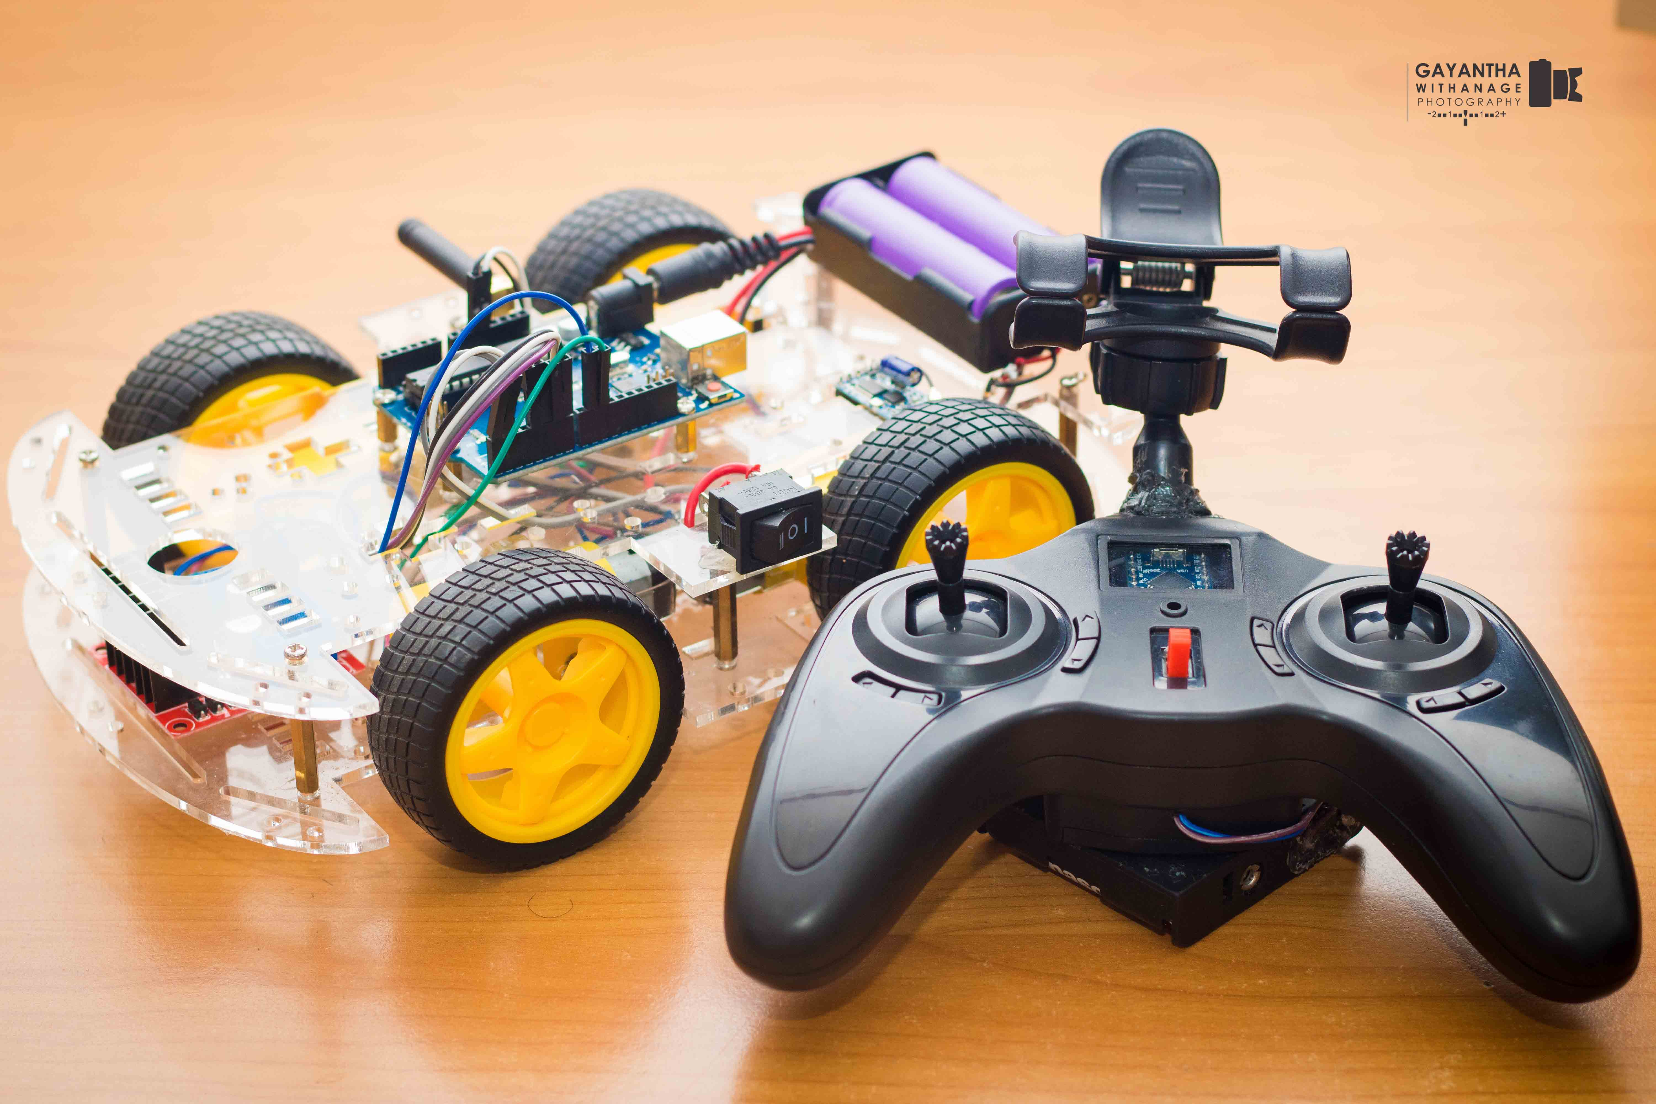Tasks undertaken and outcomes

* In this project I have to create a robot with a remote controlling system
* So if any disaster or any emergency we can active this robot and remotely directed to that particular place to measure the damage estimate. After that we can suggest how many rescue teams should want to that incident.

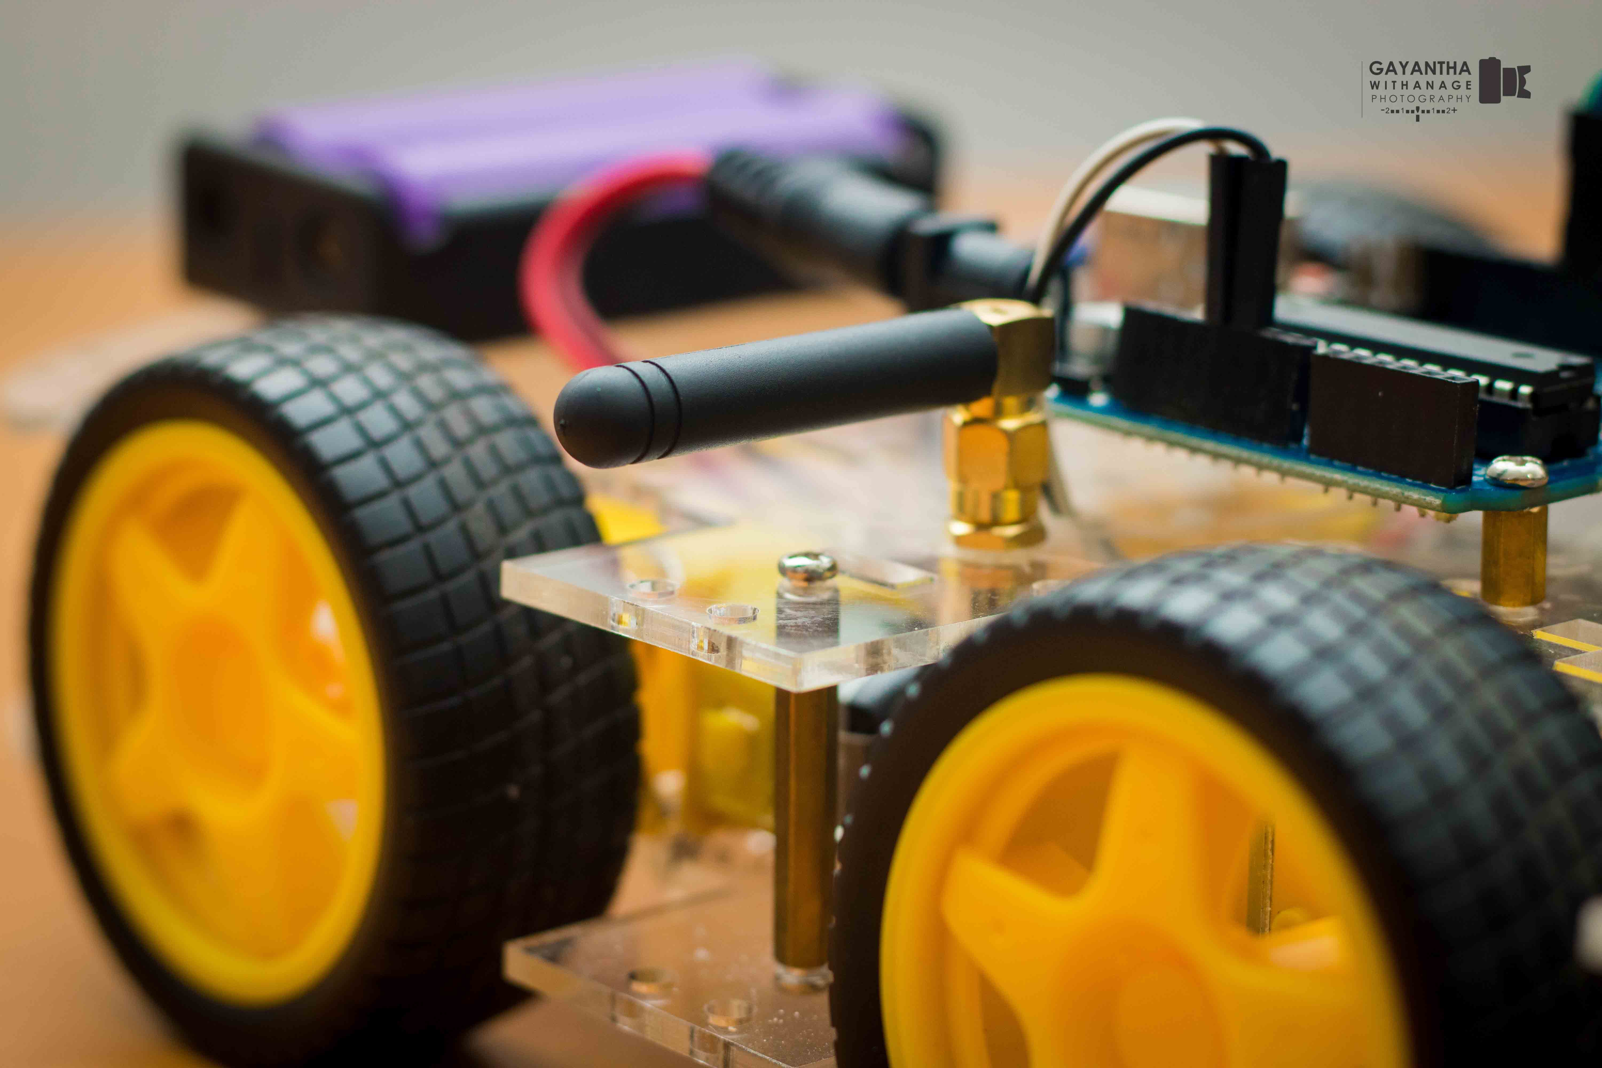

* 433 MHz Antenna

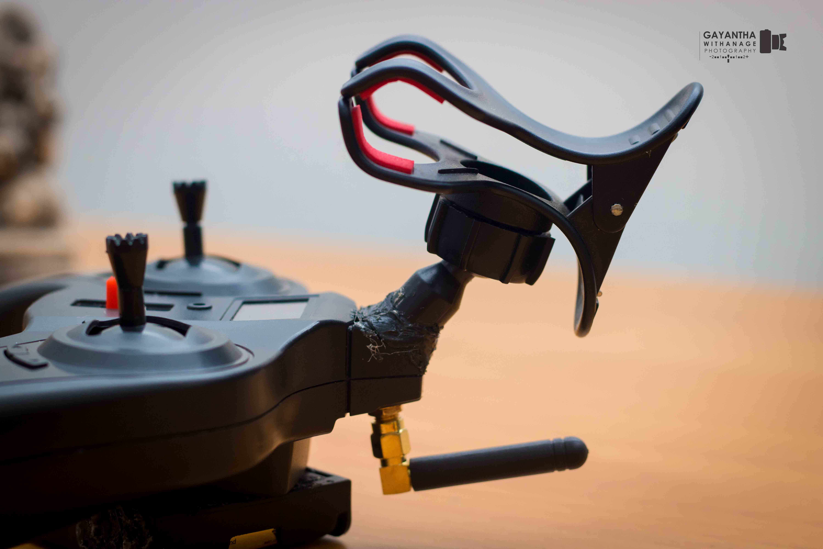

* We use HC-12 module for connect this. (We can handle our robot for 1.5 km.
* Well maintaining and updated web site is another outcome of this project. That will contain the all disaster details in an order.
* MVC architecture model to create the web.
* ASP.net
* 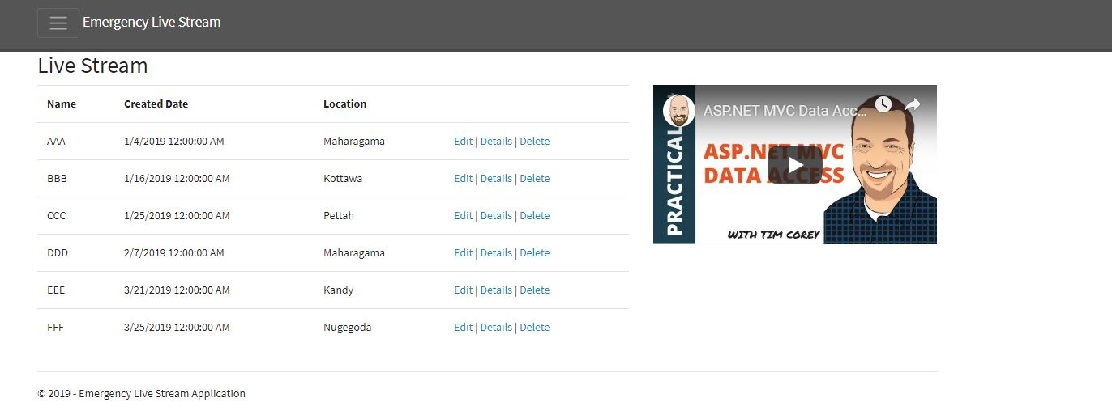Bootstrap 4

(Sample Image of the web page)

3. Products produced and product quality

* In this project the main task is to build a full remote controlled Arduino 4-wheel robot that can controlled within 1.5km.
* Also I added thermistor to calculate the temperature.
  + By using that we can calculate the heat temperature in that particular incident.
  + Added new feature to the web as well. That will contain the particular temperature in the incidents.

* 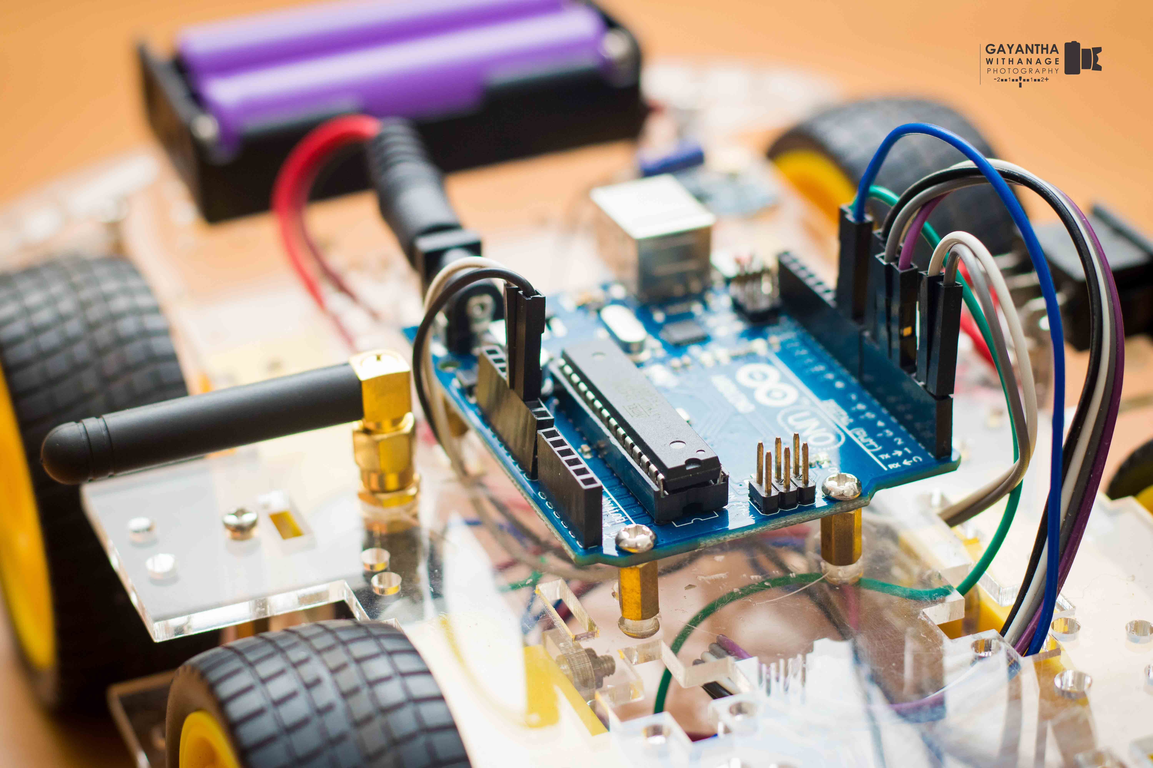Safe Robot
* Arduino robot will build using the high quality network components and other



Arduino equipment.

* 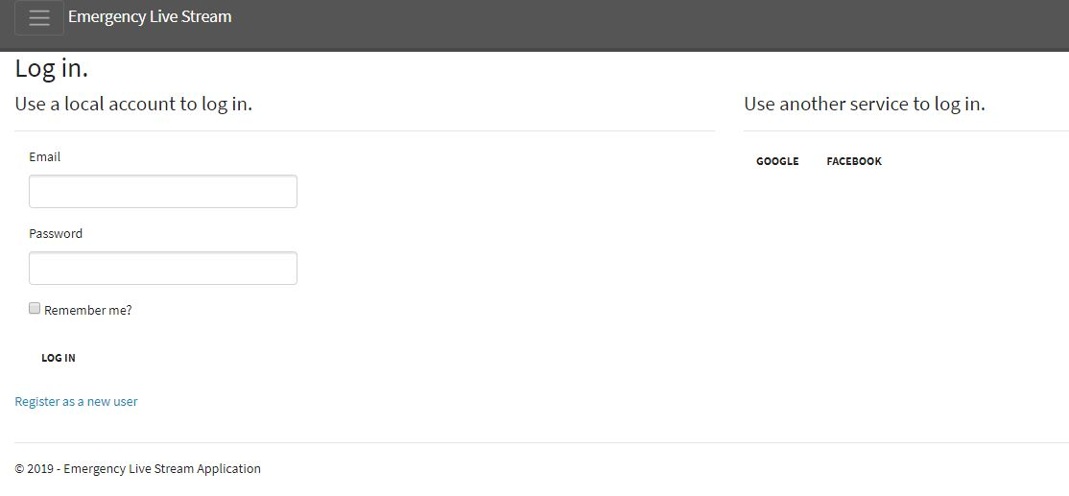People can log in to the web using FB and Google login as well.

4. Risks that have materialised

* Connection between the Arduino tool kits.
* Controlling errors – Remote controlling difficulties
* Network connectivity Issues
* FB and Google access to the Web
* Temperature measurement

5. Schedule

|  |  |  |
| --- | --- | --- |
| Component | Deadline | Description |
| * Add Thermistor | 10/03 | Finalizing the Arduino robot.  Troubleshooting |
| * Creating the Web and Testing | 20/03 | Finalizing the web site and test it. |

6. Resources

* + Arduino IDE / Arduino materials
  + Wireless Camera
  + 433 MHz Antenna
  + XY joystick module
  + 18650 Battery
  + Transistors and Receivers
  + 10K NTC thermistor
  + ESP-8266 serial WIFI module
  + USB RS232 TTL Converter Adapter

Resources should be available and safety. That means if any harm we can easily fix the components and the robot without any delay.

7. Student learning undertaken & required

* Trouble shooting with the errors that will occur in Arduino tools.
* Fixing the Arduino robot without any mistakes
* Knowledge about ASP.net
* Coding in Arduino IDE
* Knowledge in new software components and applications.
* Handling new Arduino components
* Maintaining the Web
* By using this system, we can save the people life and get the quick reactions in any incident.
* All requirements and design principles will be checked.

8. Draft Table of Content – Final Report

1. – Introduction
2. – Analysis
   1. – Existing System
   2. – Rescue Monitoring System
      1. – Components
      2. – Arduino Robot
      3. –Web

This is a draft Table of content regarding to Final Report. This could be modifying in Final Report. That means some of the above mentioned topic headings can be modified with a different name in final report. Also 1.0 and 2.0 only included for this report.

# 15.0 Supervisory meeting minutes

